Pork fillet stuffed with black pudding,
apple and sage
Complexity: Medium

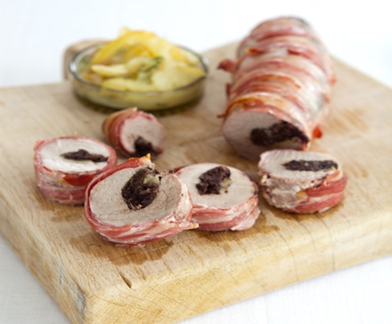
Ingredients
¼ eating apple
2-3 sage laves
25g black pudding
170g pork tenderloin fillet
5 lean dry-cured rashers streaky bacon

Sage and Apple Sauce (to share between two)
2 cooking apples
1 x 15ml spoon granulated sugar
2 x 15ml spoon water
2 fresh sage leaves
10g butter

Equipment
Non-stick baking tray, apple corer, 2 x vegetable knives, chopping board, small bowl, red chopping board, vegetable peeler, saucepan with a lid, measuring spoons, wooden spoon, pan stand.

Method
- Preheat the oven to gas mark 5, 190°C.
- Place a baking tray in the oven to preheat.
- Core and slice the eating apple.
- Wash the sage leaves.
- Crumble the black pudding.
- Place the pork fillet on a red chopping board and with a sharp knife make a horizontal slit along the length of the fillet to make a pocket.
- Take the apple slices and arrange in a single layer along the length of the pocket. Arrange the black pudding on top of the apple slices.
- Cover the black pudding with a layer of the sage leaves. Hold together the cut edges of the fillet. Wrap the bacon rashers around the fillet until it is completely covered.
- Place the fillet on the preheated tray and then thoroughly wash and dry your hands.
- Roast for about 30 minutes until the bacon is crispy and the juices from the meat run clear.

To make the sauce:
- Peel, core and thickly slice the cooking apple and place in a saucepan with the remainder of the eating apple slices.
- Roughly chop the sage leaves and add to the saucepan.
- Add the granulated sugar, water and butter.
- Cover the saucepan and simmer for 10 minutes to soften the ingredients.
- Stir well and put to one side, with the lid on, until ready to serve.

Top tips
- Look for the Red Tractor badge when buying pork.
- Serve the fillet slices with the apple sauce, new potatoes and red cabbage
- The recipe also tastes good cold with salad.

Food skills
- Weigh.
- Measure.
- Core.
- Slice.
- Layer.
- Roast.

