Pork, plum and sage pasties
Complexity: Medium-High

Ingredients
200g plain flour 100g butter or margarine
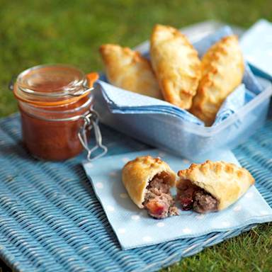
2-3 x 15ml spoons cold water 2 fresh plums
1 x 15ml spoon fresh sage
225g lean mince pork
1 x 15ml spoon plum jam
Black pepper
1 egg
1 x 15ml spoon milk

Equipment
Sieve, large bowl, weighing scales, measuring spoons, table knife, cling film, knife, chopping board, rolling pin, flour dredger, pastry cutter, small bowl, fork, pastry brush, baking tray, oven gloves.

Method
- Pre-heat the oven to 180ºC or Gas Mark 4.
- Make up the pastry:
  - sift the flour into the bowl;
  - rub the butter or margarine into the flour, using your fingertips, until it resembles breadcrumbs;
  - add the cold water;
  - mix to form a firm, smooth dough;
  - cover the dough with cling film and place in the refrigerator for at least 30 minutes, if time permits.
- Prepare the ingredients:
  - de-stone and chop the plums;
  - chop the sage roughly.
- Mix the pork mince, plums, jam, sage and a few twists of black pepper together in a large bowl.
- Divide the dough into 5 equal portions and shape into balls.
- Roll out each portion into a circle approximately 17cm in diameter, on a floured surface.
- Place a large spoonful of the mince mixture into the centre of the circle.
- Beat the egg and milk together in a small bowl and brush the edges of the pastry circles.
- Fold the pastry over the meat mixture and press together, sealing with a crimp pattern.
- Brush with the egg and milk glaze, and transfer to a baking tray.
- Bake for 25-30 minutes, until the pastry is golden brown.

Top tips
- Serve hot or cold, great with a fruity relish or chutney.
- To save time use premade pastry.

Food skills
- Weigh.
- Measure.
- Sift.
- Rub in.
- Mix.
- Chill.
- Chop.
- Divide and portion.
- Roll out.
- Beat.
- Fold.
- Glaze.
- Bake.

