Raised pork pie
Complexity: High

Ingredients

250g strong plain flour

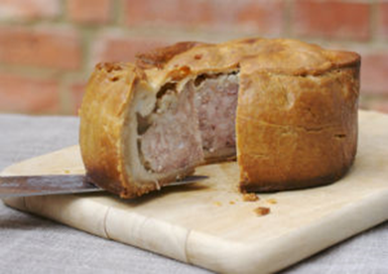
½ x 5ml spoon salt

100g lard

25g margarine

125ml water

50g bread

3 x 15ml spoon milk

½ x 5ml spoon fresh sage

300g boneless shoulder of pork

100g bacon

Black pepper

2 eggs

125ml water

½ x pork stock cube

5g gelatine

Equipment
Pie mould, weighing scales, large mixing bowl, small saucepan, measuring jug, flour dredger, rolling pin, 2 x small bowl, measuring spoons, knife, 2 x chopping boards, cling film, fork, pastry brush, oven gloves, baking tray, kettle.

Method
- Pre-heat the oven to 230 - 250⁰C or Gas mark 8.
- Grease the pie mould.
- Sift the flour and salt into a large bowl.
- Boil the lard, margarine and water together in a small saucepan.
- Pour the boiling liquid into the flour.
- Mix the ingredients together until a smooth paste is formed and cover.
- Soak the bread in milk in a small bowl.
- Finely chop the sage.
- Using a clean knife and chopping board cut the pork and bacon into small even pieces.
- Mix the bread, sage, pork, bacon and black pepper in a large mixing bowl.
- Divide the pastry into quarters and set one quarter aside covered and in a warm place.
- Roll out three-quarters of the pastry on a lightly floured surface.
- Line the pie mould with the pastry and carefully trim the edges.
- Place the pork filling in the middle of the pie mould and press down firmly
- Roll out the remaining pastry to make a lid.
- Beat the egg in a small bowl.
- Brush the edges of the pie and lid with beaten egg.
- Place the pastry lid on top of the pie and crimp the edges closed.
- Pierce a 1cm diameter hole in the centre of the pie lid
- Brush the top of the pork pie with beaten egg.
- Bake in the oven for 1½ - 2 hours.
- Remove the pie from the pie mould and place on a baking tray.
- Brush the sides of the pie with beaten egg and return to the oven for 5 minutes or until golden brown.
- Make up the stock and add the gelatine.
- Remove from the oven and fill with the stock and gelatine.

Top tips
- The pork pies can be served cold with pickles and a suitable salad.
- Left-over pastry can be used to make decorations on the lid of the pork pie.
- If the pie browns too quickly in the oven, cover with greaseproof paper or foil.

Food skills
- Weigh.
- Measure.
- Sift.
- Boil.
- Mix.
- Chop and cut.
- Divide.
- Roll out.
- Beat.
- Glaze.
- Layer.
- Bake.

