Thai beef noodle salad
Complexity: Medium-High

Ingredients

100g rice noodles

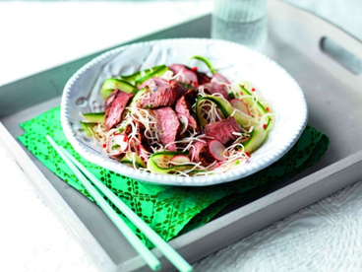
2 lean beef rump steaks

Black pepper

3 x 15ml spoon Teriyaki sauce

1 x 5ml spoon sesame oil

2 x 15ml spoon fresh mint

½ lime

8 radishes

½ cucumber

1 red chilli

1 x 15ml spoon Thai fish sauce

Equipment

Weighing scales, saucepan, shallow dish, measuring spoons, cling film, colander, knife, chopping board, juicer, vegetable peeler, small bowl, mixing spoon, tongs, plate, large bowl, serving plate.

Method
- Cook the noodles according to the packet instructions.
- Place the steaks in a shallow dish and season with the pepper. Add the Teriyaki sauce and oil. Coat well. Cover and marinate in the refrigerator for 20 minutes, if time permits.
- Drain the cooked noodles and set aside to cool.
- Prepare the ingredients:
  - chop the mint;
  - juice the lime;
  - thinly slice the radishes;
  - thinly slice the cucumber into ribbons, using a vegetable peeler;
  - deseed and finely chop the chilli.
- Mix the lime juice, Thai fish sauce and mint together in a small bowl and set aside.
- Heat a non-stick frying or griddle pan, remove the steaks from the marinade and cook on each side according to your preference (based on a 2cm steak):
  - Rare: 2½ minutes each side;
  - Medium: 4 minutes each side;
  - Well done: 6 minutes each side.
- Transfer to a warm plate and leave to rest for 1-2 minutes.
- Mix the noodles, radish, cucumber and chilli in a large bowl and transfer to a serving plate.
- Slice the steak and arrange over the salad.
- Stir the lime juice dressing and drizzle over the salad.

Top tips
- The steaks can also be cooked under a preheated moderate grill.

Food skills
- Weigh.
- Measure.
- Coat.
- Chill.
- Drain.
- Chop and slice.
- Juice.
- Fry.
- Mix and stir.

