Turkey burgers
Complexity: medium
Ingredients
1 small onion
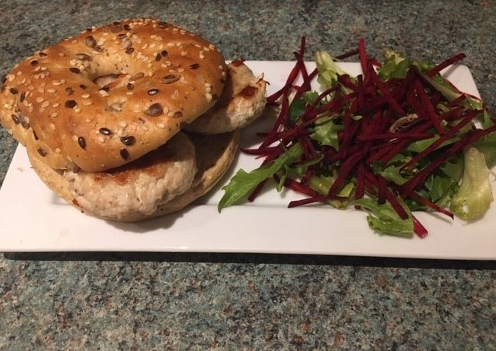
250g lean turkey mince
1 x 5ml spoon dried mixed herbs
1 x 5ml spoon Worcestershire sauce
Ground black pepper

To serve:
2 wholemeal rolls, bagels or pitta bread
1 tomato
Lettuce leaves or mixed salad
Pickled gherkin (optional)

Equipment
Chopping board, vegetable knife, mixing bowl, mixing spoon, weighing scales, measuring spoons, grill pan, pastry brush, bread knife.

Method
- Peel and finely chop the onion.
- Place the mince, onion, mixed herbs and Worcestershire sauce in a bowl. Season with black pepper.
- Mix the mince mixture together.
- Preheat the grill at medium.
- Divide the mince mixture into 4 and shape into burgers. Thoroughly wash and dry your hands after touching the raw meat.
- Place burgers on a grill tray and grill for 5-6 minutes each side. Check that the burgers are thoroughly cooked and there are no pink juices.
- While the burgers are cooking, shred the lettuce and slice the tomato.
- When the burgers are cooked, assemble each burger.

Top tips
- Experiment using different herbs and spices to flavour the burgers.
- Use extra salad ingredients – they all count towards your 5 A Day.
- Try using pork, lamb or beef mince.
- Add grated/chopped vegetables to the burger, such as carrot, courgette or mushroom.

Food skills
Weigh
Measure
Chop and slice
Mix
Form and shape
Grill

