White sauce
Complexity: low-medium
Ingredients

25g butter or baking fat/block

25g plain flour

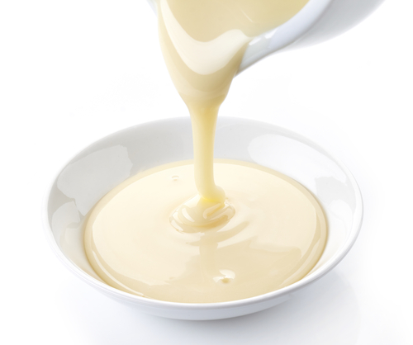
300ml milk

Equipment

Saucepan, measuring jug, wooden spoon.

Method - roux

- Melt the butter/baking fat in a saucepan over a medium heat. Pour in the flour off the heat and stir well. This should make a thick paste. Cook paste for one minute or until it bubbles.
- Slowly add a little milk off the heat. Bring to the boil.
- Add a little more milk off the heat. Bring back to the boil again.
- Continue to add the milk in this way, making sure the mixture boils each time, until all the milk has been used.
- Taste and season with pepper if necessary.

Method – all in one

- Put the milk in a saucepan and then simply add the flour and butter/baking fat and bring everything gradually up to simmering point whisking continuously with a whisk until the sauce has thickened and is smooth and glossy.
- The turn down the heat to its lowest possible setting and let the sauce cook very gently for 5 minutes, stirring from time to time.
- Taste and season with pepper if necessary.

Top tips
- To make a cheese sauce, add 75g grated cheese off the heat once the sauce is cooked. The heat of the sauce will melt the cheese.

Food skills
Weigh and measure
Melt
Stir
Boil
Simmer
Whisk

