Breakfast muffins

Ingredients
Complexity: medium
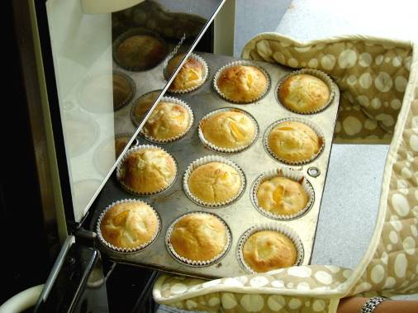
100g carrot, apple or pear
255g self-raising flour
2 x 5ml spoons baking powder
100g white caster sugar
2 x 5ml level spoons ginger, cinnamon or mixed spice
1 egg
240ml semi skimmed milk
90ml vegetable oil

Equipment
Muffin tray, 8-10 muffin cases, chopping board, vegetable knife, peeler, grater, small bowl, large mixing bowl, sieve, measuring spoon, mixing spoon, measuring jug, fork.

Method
- Preheat oven to 200°C or gas mark 6.
- Line a 12 hole muffin tin with paper cases.
- Prepare fruit or vegetables:
- cut the top and bottom off the carrot and peel (if using);
- wash the apple or pear (if using) but do not peel;
- grate the carrot, apple or pear and put aside in a small bowl.
- In a large bowl, sift together: flour, baking powder and sugar along with the ginger, cinnamon or mixed spice.
- Crack the egg into a jug and whisk with a fork. Wash hands after touching raw egg.
- Stir in milk and oil.
- Pour all liquid ingredients into the dry mixture. Stir just until combined, scraping sides and bottom of the bowl as you stir. Mixing should take only about 30 seconds. The batter will be lumpy but no dry flour should be visible. Do not over stir.
- Add the grated carrot, apple or pear. Mix gently.
- Divide the mixture equally among the muffin cases.
- Add toppings if desired.
- Bake for 20 - 25 minutes.

Top tips
- Try using a variety of vegetables such as grated courgette or parsnip or even mashed avocado. Add herbs or spices such as oregano, rosemary or chilli.
- Add a mashed banana instead of the grated carrot, apple or pear.
- You could use berries that are in season, such as raspberries, blackberries or blueberries.
- Try dried fruit such as raisins, sultanas, cherries, apricots or mixed peel.
- Add extra toppings to the muffins, such as chopped nuts, crumble, desiccated coconut or pumpkin seeds.

Food skills
- Weigh and measure.
- Cut.
- Grate.
- Sift.
- Whisk.
- Mix, stir and combine.
- Divide.
- Bake.

