Spicy chickpea and

mushroom burgers
Complexity: medium
Ingredients
1 slice of bread from a large loaf
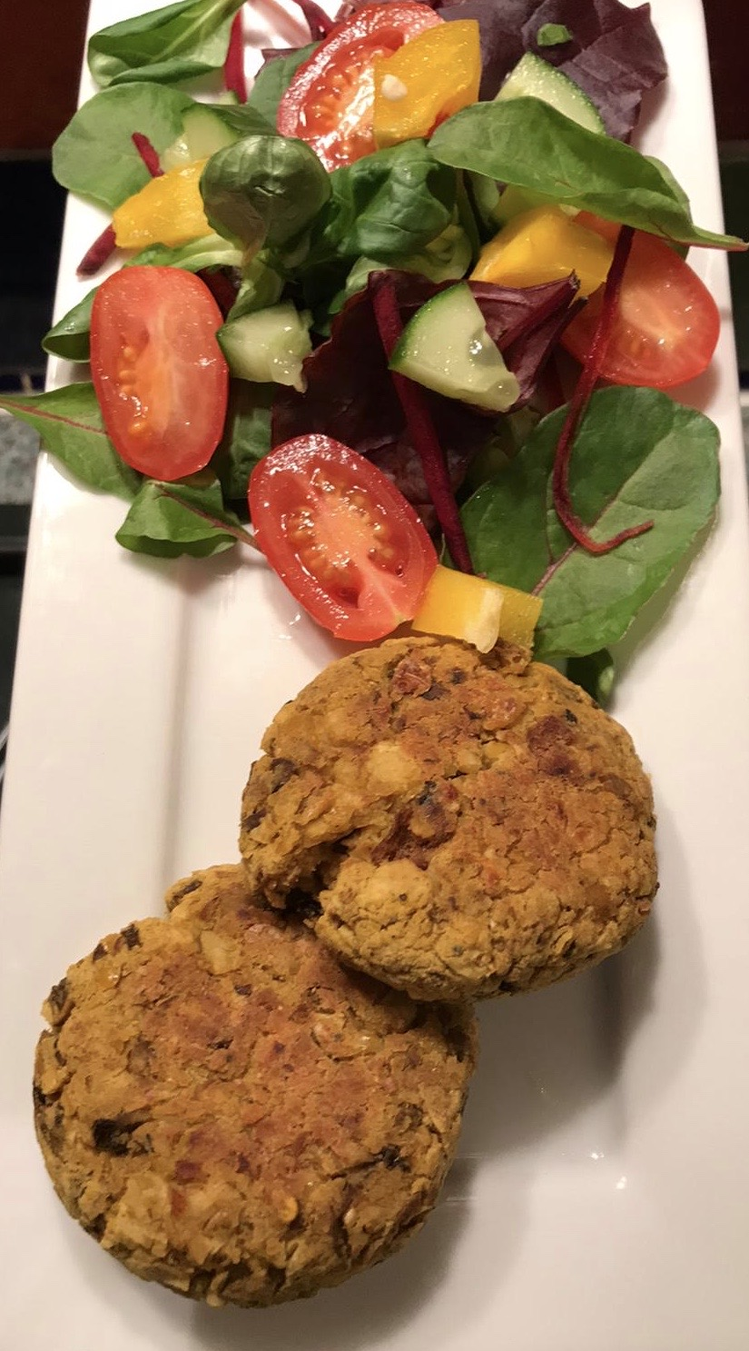
1 large clove of garlic
125g mushrooms
1 x 5ml spoon smoked paprika
Spray oil
200g chickpeas

Equipment
Food processor, garlic press, sharp knife, chopping board, measuring spoon, frying pan, can opener, large mixing bowl, fork, grill pan, fish slice.

Method
- Preheat the grill.
- Blitz the bread in a food processor to make breadcrumbs.
- Peel and crush the garlic.
- Finely chop the mushrooms.
- Using the spray oil, fry the mushrooms gently with the garlic and paprika for five minutes until soft.
- Drain the chickpeas and mash with a fork.
- Mix all the ingredients together.
- Shape into 4 even sized burgers.
- Grill the burgers for 8 minutes, turning over half way through.

Top tips
- Swap the chickpeas with different beans, e.g. borlotti beans, kidney beans, butter beans.
- Add cooked mashed vegetables to the burger mixture, e.g. sweet potato, carrot, butternut squash.
- Use different herbs and spices, e.g. basil, chilli flakes or curry powder.
- Use granary bread for the breadcrumbs for added texture.

Food skills
- Mix and stir.
- Divide and shape.
- Grill.

- Fry.
- Mash.

- Crush.
- Cut and chop.

- Blitz.
- Peel.

- Weigh.
- Measure.

