Fruit scones

Ingredients
Complexity: medium
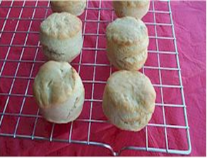
1 large eating apple or pear
250g self raising flour
40g butter or baking fat/block
1 x 5ml spoon ground ginger, cinnamon or mixed spice
25g sugar
125ml semi-skimmed milk

Equipment
Non-stick baking tray, pastry brush, grater, weighing scales, sieve, mixing bowl, measuring spoons, mixing spoon, measuring jug, flour dredger, rolling pin, scone cutter, cooling rack.

Method
- Preheat oven to 220°C or gas mark 7.
- Grease or line the baking tray.
- Wash and grate the apple or pear (do not peel).
- Sift the flour into the bowl.
- Rub the fat into the flour until it resembles breadcrumbs.
- Stir in the sugar, spice and fruit.
- Make a well in the middle of the flour and carefully pour in the milk. (Save just a little of the milk).
- Mix to form a soft dough.
- Place the dough on a lightly floured work surface.
- Roll out the dough to about 1½cm thick.
- Shape the scones using a cutter.
- Place the scones on a baking tray and brush each top with a little milk.
- Bake for 12 – 15 minutes, until golden brown.
- Allow to cool on a cooling rack.

Top tips
- Experiment with different flavours and textures by using fresh or canned fruit, such as mango, plum, nectarine, peach or pineapple.
- To make cheese scones, sift 1 x 5ml mustard with the flour and add 75g grated cheese before you add the milk. Do not add the sugar.
- Traditionally, fluted scone cutters are used for sweet scones and plain cutters for savoury scones.

Food skills
- Bake.

- Roll out.
- Form and shape.

- Rub-in.
- Mix and stir.

- Grate
- Sift.

- Weigh.
- Measure.

