Healthy eating dominoes
Instructions
- Print and cut out the cards.
- Give each pupil a card.
- Ask the pupil holding the card with the vegetable sticks and dip image to read out the ‘follow me’ instruction on their card.
- The pupil with the answer (an image) stands next to the first pupil and then reads out the ‘follow me’ instruction on their card.
- The pupils should continue until the last pupil can match their ‘follow me’ instruction with the first image card (vegetable sticks and dip).

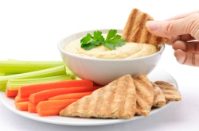  Vegetable sticks and dip | Follow me if you are a good source of calcium… |   Milk | Follow me if you are an oily fish…
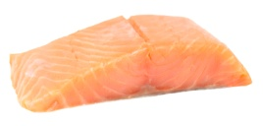  Salmon | Follow me if you are a drink which counts towards 5 A DAY… |   Orange juice | Follow me if you are a vegetarian source of protein…
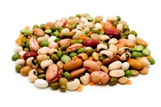  Beans and pulses | Follow me if you should only eat a maximum of 6g a day… | 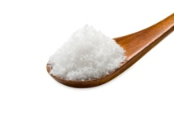  Salt | Follow me if you are a healthy breakfast option…
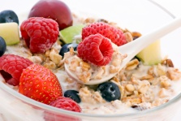  Fruit and muesli | Follow me if you are a higher in fibre alternative to white pasta… | Wholemeal spaghetti  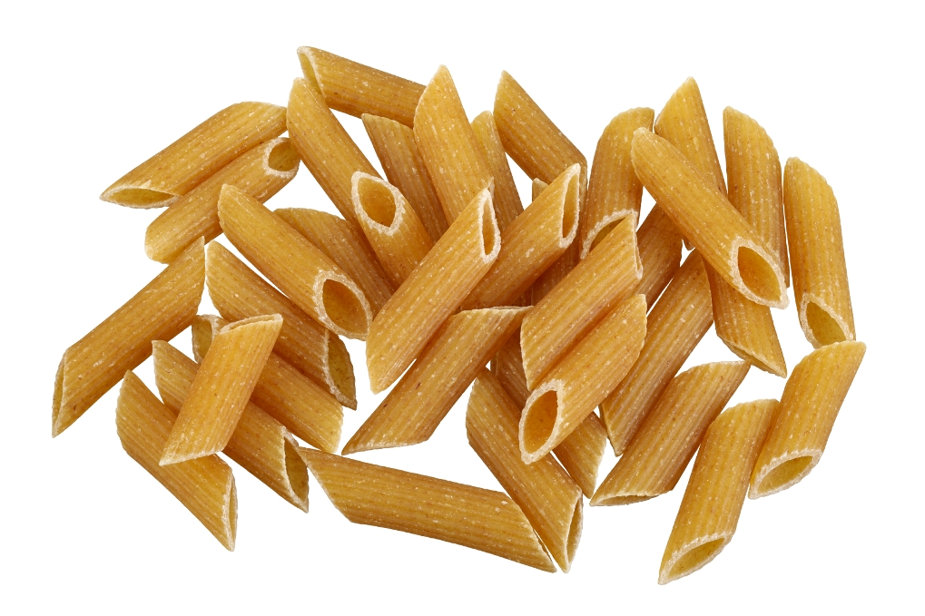 | Follow me if you are a good source of unsaturated fats…
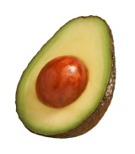  Avocado | Follow me if you are high in fat and high in sugar… |   Chocolate cake | Follow me if you are a food high in iron…
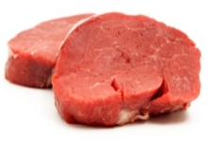  Beef steak | Follow me if you are a non-oily fish… | 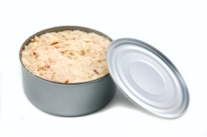  Canned tuna | Follow me if you are cooking oil high in unsaturated fats…
  Olive oil | Follow me if you are fortified with thiamine, calcium, iron and niacin… | 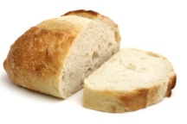  White bread | Follow me if you are a drink which should be consumed regularly…
  Water | Follow me if you are a healthy snack option…

