Ideas for using the meal cards

- Sort the cards into breakfast, lunch and dinner.
- List the ingredients used in each recipe.
- Name the ingredients that fit into each of the Eatwell Guide food groups.
- List two fruit or vegetables you could add to the dishes to increase your 5 A DAY.
- Suggest two ways in which you could reduce the fat or salt content of the dish or increase the amount of fibre.
- Suggest how the dishes could be made into a complete meal, e.g. add a drink or a side salad.

Beef burger with cheese, lettuce and tomato


Beef Goulash with carrots and potato
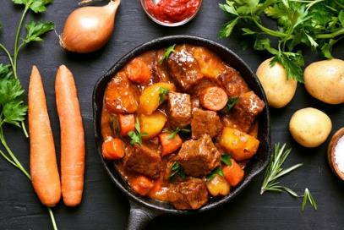

Salmon fish fingers with wedges


Chicken stir fry with wholegrain noodles
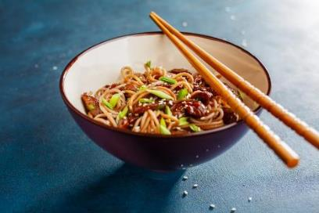

Bacon lettuce and tomato sandwich (BLT)

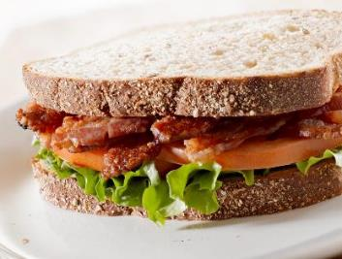

Burritos (vegetarian) with red kidney beans
and mixed vegetables
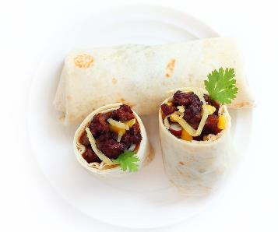

Carrot soup
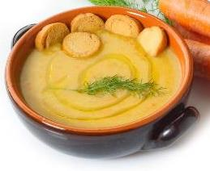

Cheese and ham omelette


Ham, cheese and rocket pizza
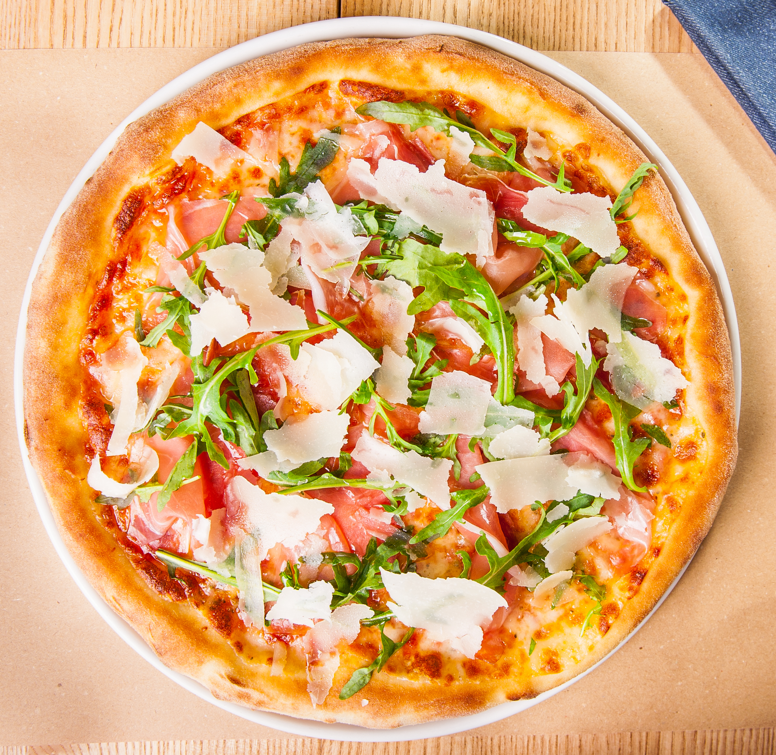

Chicken curry, spring onions and sugar snap peas

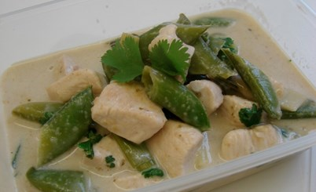

Creamy chicken and mushroom pie
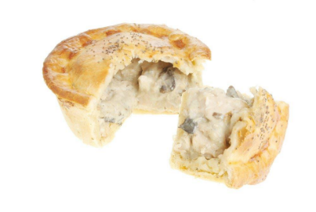

Cheese and tomato quiche



Cottage pie
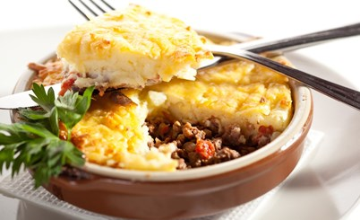

Egg and salad baguette



Fish pie with peas and lemon garnish
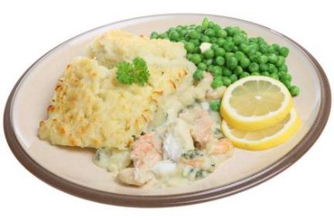

Gnocchi (made from potato) with tomato sauce

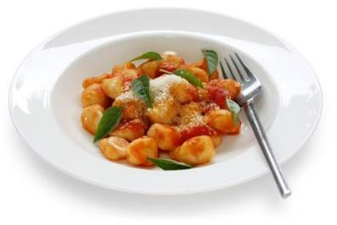

Jacket potato with cottage cheese and salad
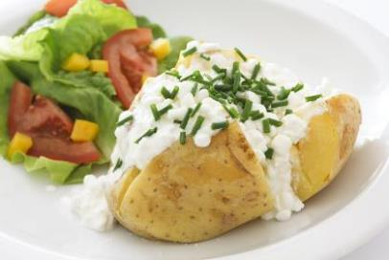

Lamb Rogan Josh
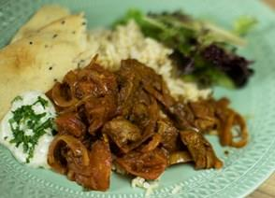

Macaroni and cheese sauce
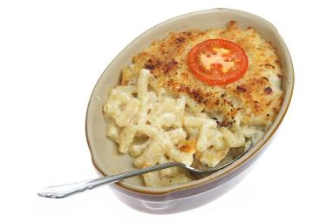

Beef lasagne
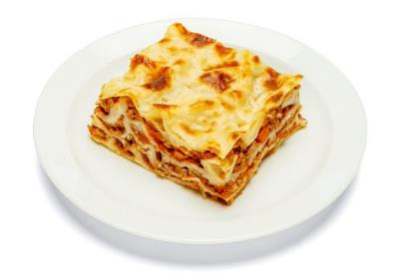

Ratatouille
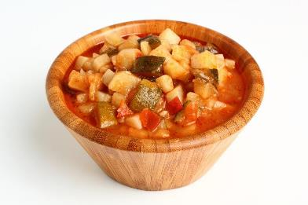

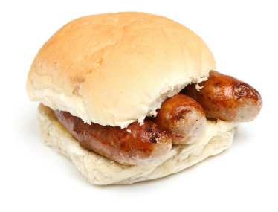
Sausages in a roll

Scrambled egg on toast
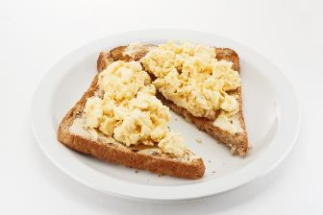

Muesli with semi-skimmed milk and berries
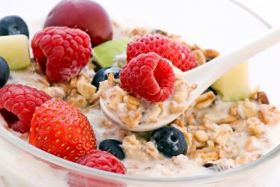

Roast lamb, roast potatoes, carrots,
peas and broccoli
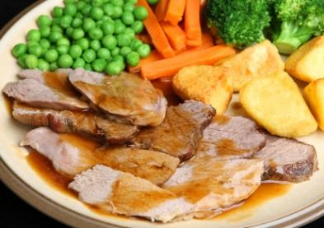

Lamb meatballs in a tomato sauce with spaghetti
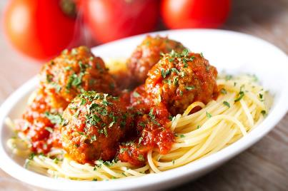

Cooked breakfast
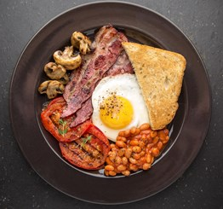

Stuffed peppers with lamb and quinoa

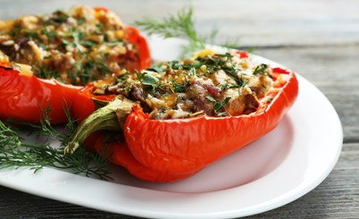

Bran flakes with dried fruit and semi-skimmed milk
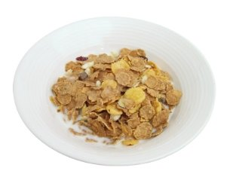

Tuna pasta bake with peas and cheese



Salmon and cucumber bagel

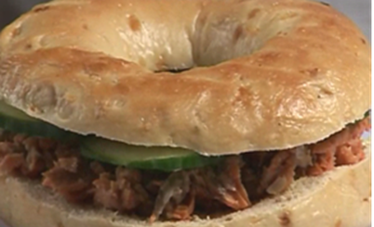

Lamb kebabs with tomatoes and courgettes

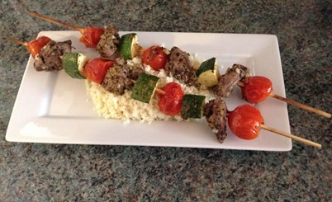

Vegetable cous cous
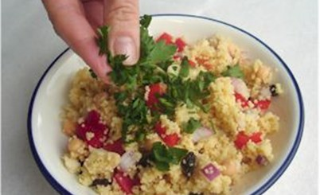

Spinach, potato and chickpea curry

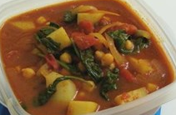

Crunchy chickpea sandwich

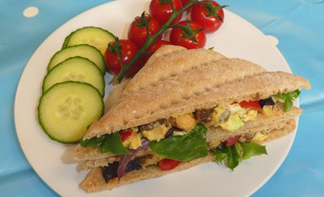

Pasta salad with mixed vegetables and
French dressing

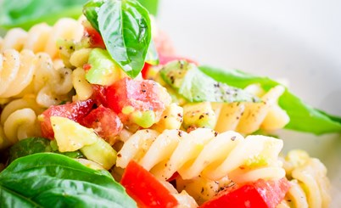

Pork Thai bites
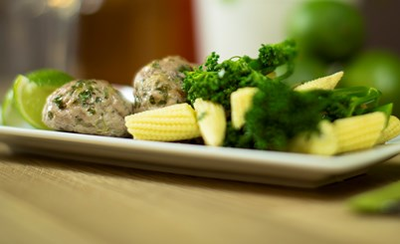

Potato salad
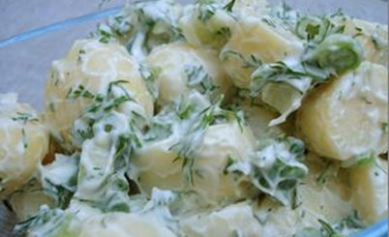

Pork jambalaya

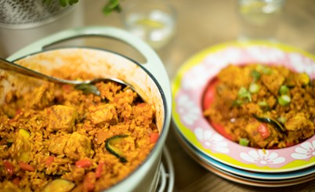

Fruit salad

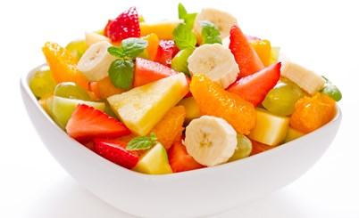

Smoked mackerel and pancetta potato salad

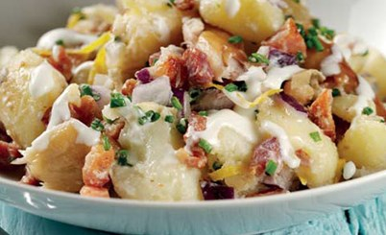

Smoked haddock samosas


Chicken fajitas
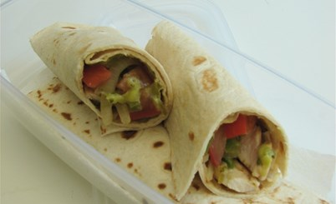

Turkey burgers

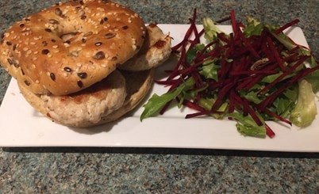

Pasta Bolognese with garlic bread
