Print the Bread jobs cards and cut into individual cards.

Next, organise the children into pairs to complete the following tasks.

1. Using the Bread jobs cards match the individual with the job they are doing.

2. Line the cards up to show the journey of bread from flour to the person buying the bread.

Millie the miller
My job is to help grind grain to make flour.

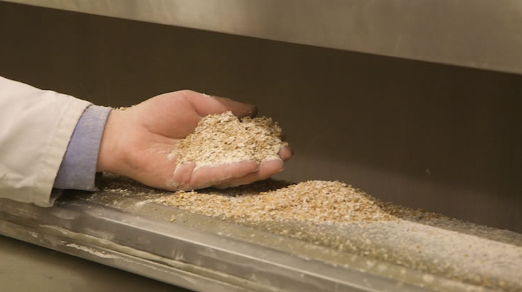
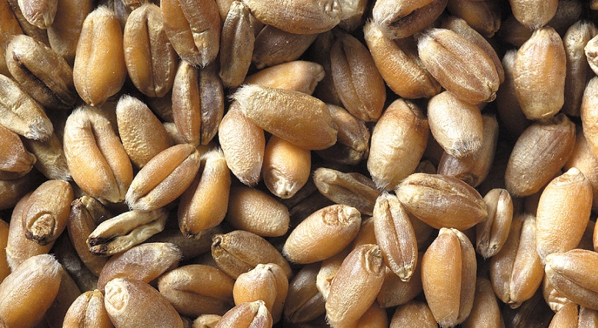

My job is to bake the bread.
Ben the baker

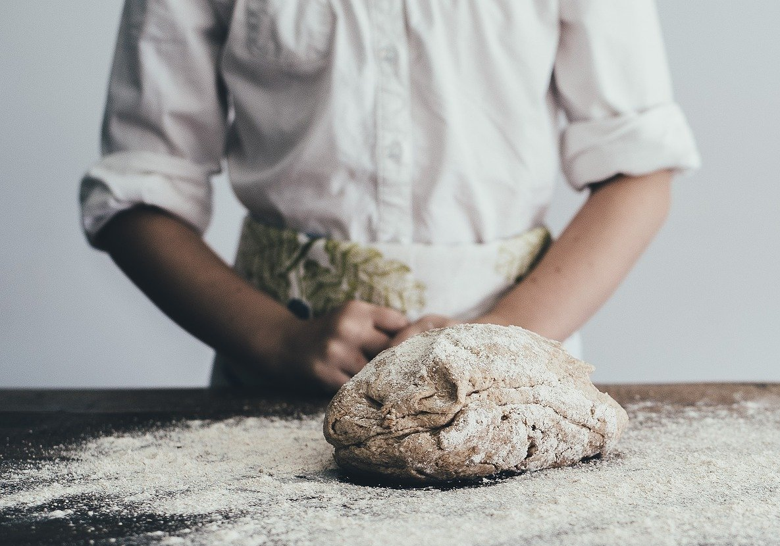
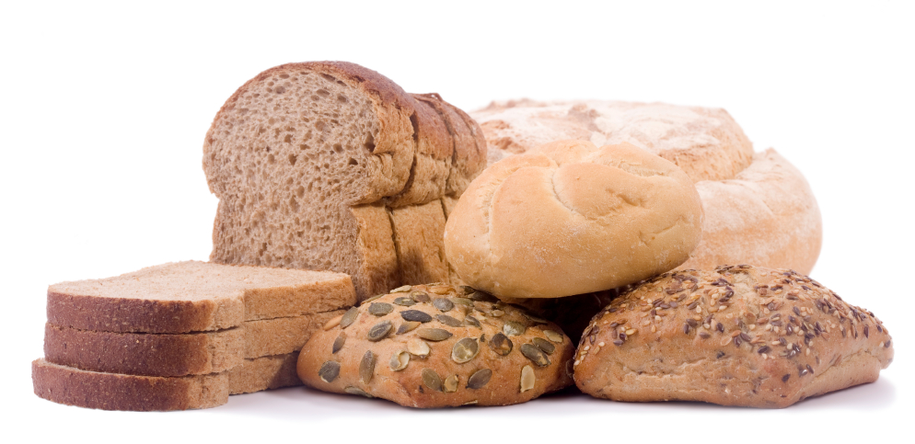

My job is to oversee the people selling the bread and manage the shop.
Suzie the shop owner





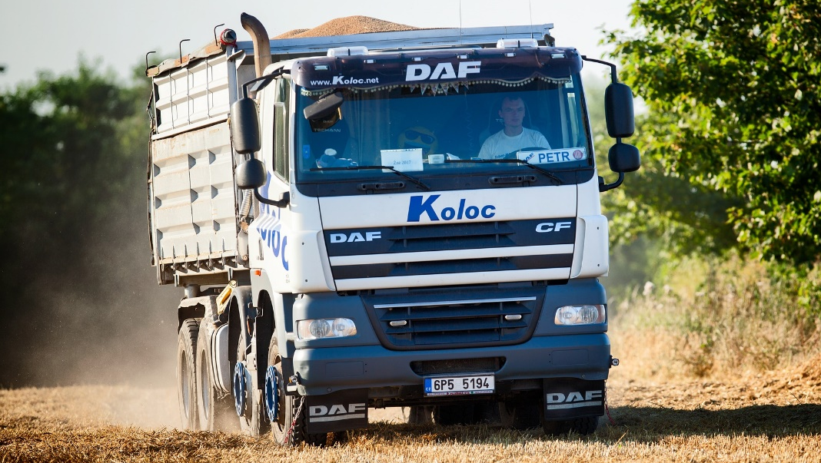
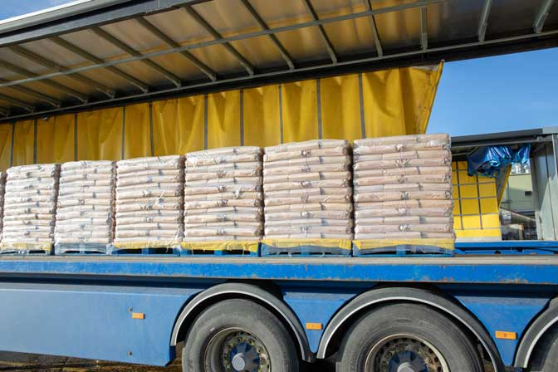
Davina the driver
My job is to drive the flour.

Carl the cashier
My job is to sell the bread in the shop.
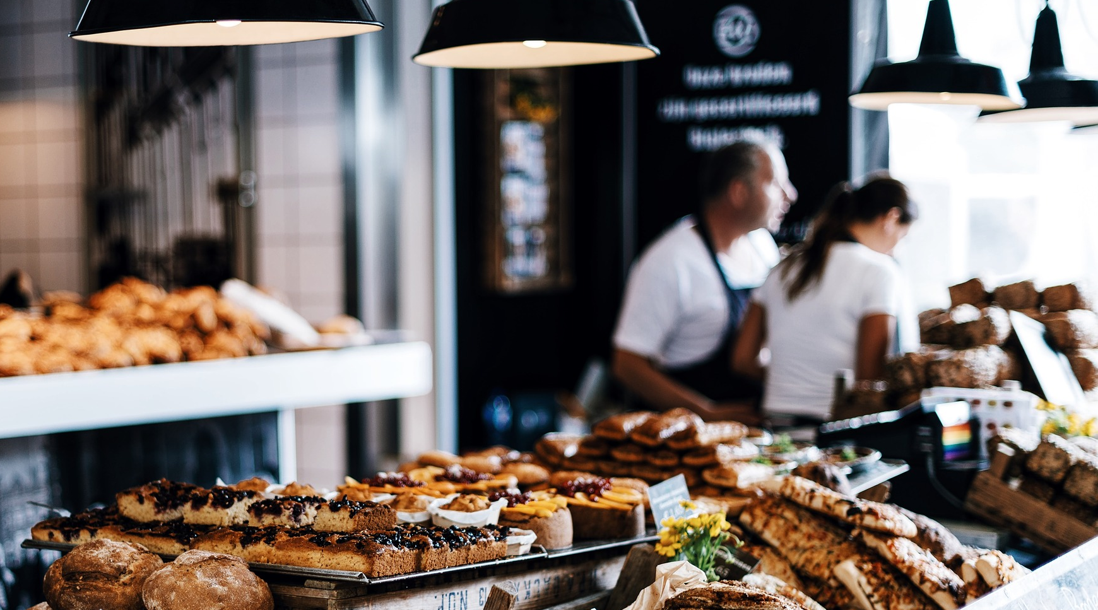

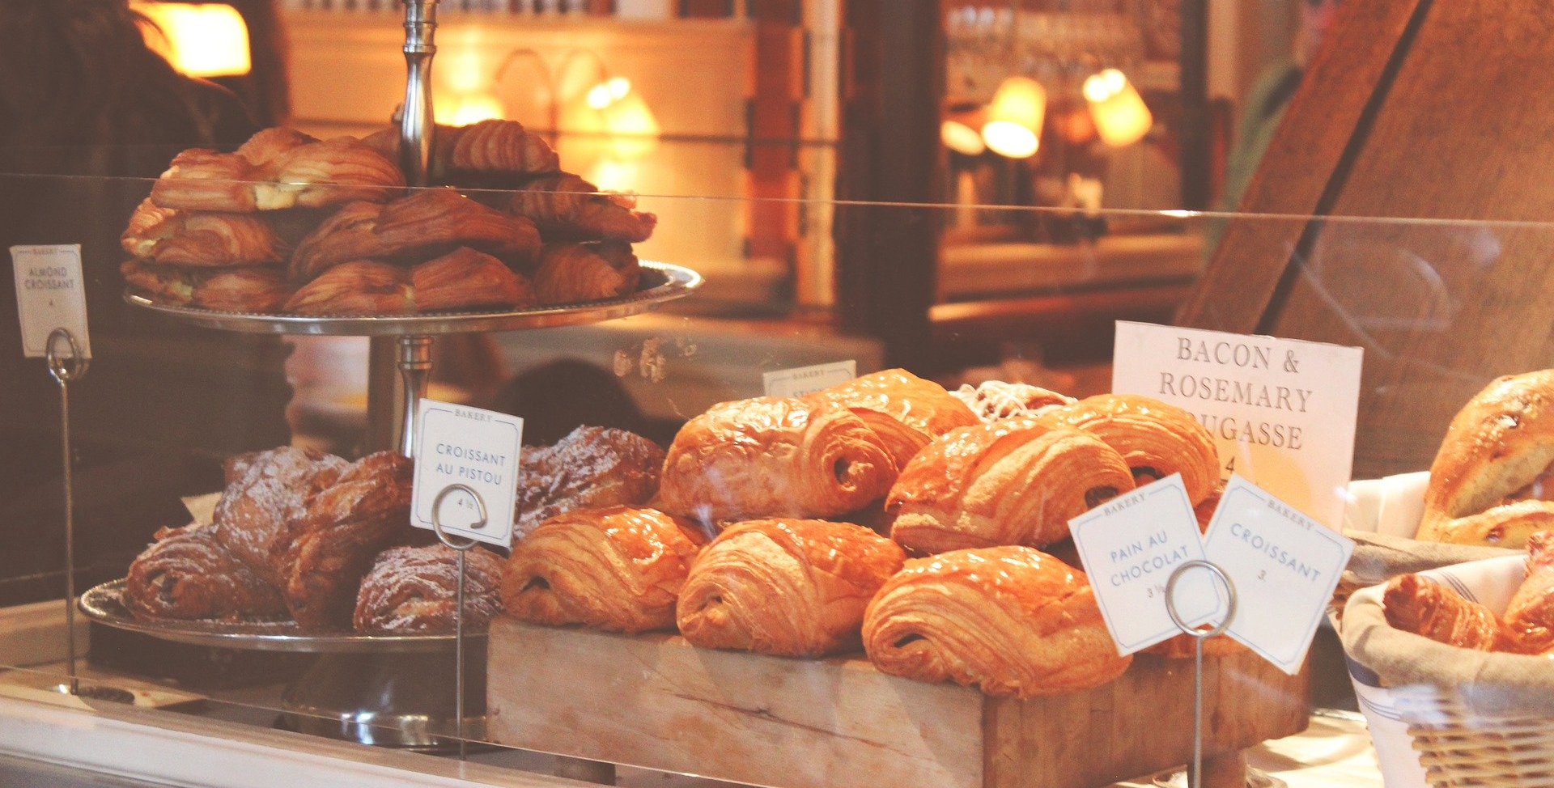

Christine the customer
I am buying the bread so that I can have it at home.

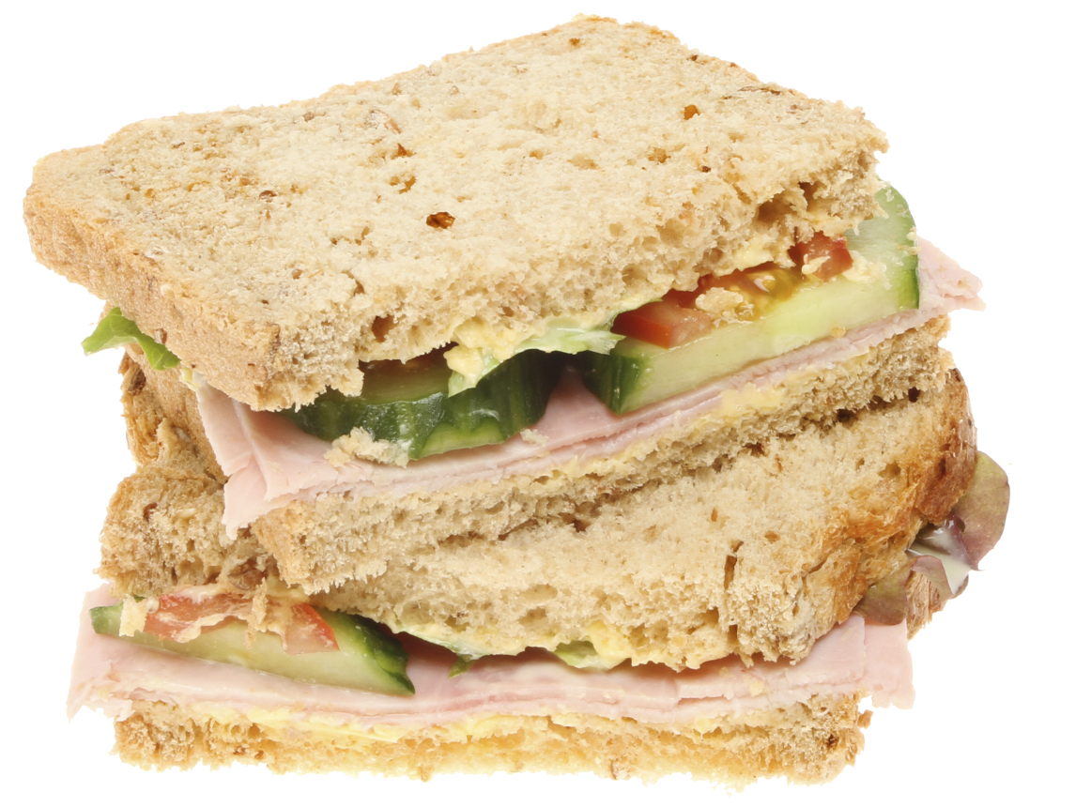


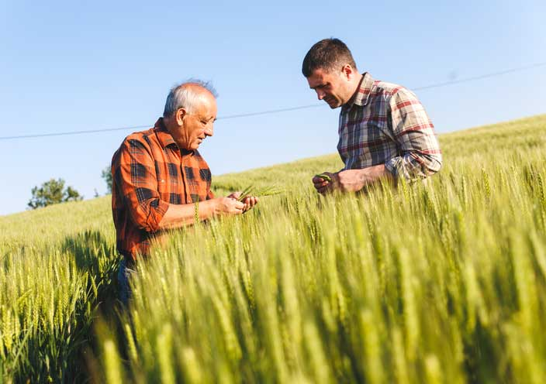
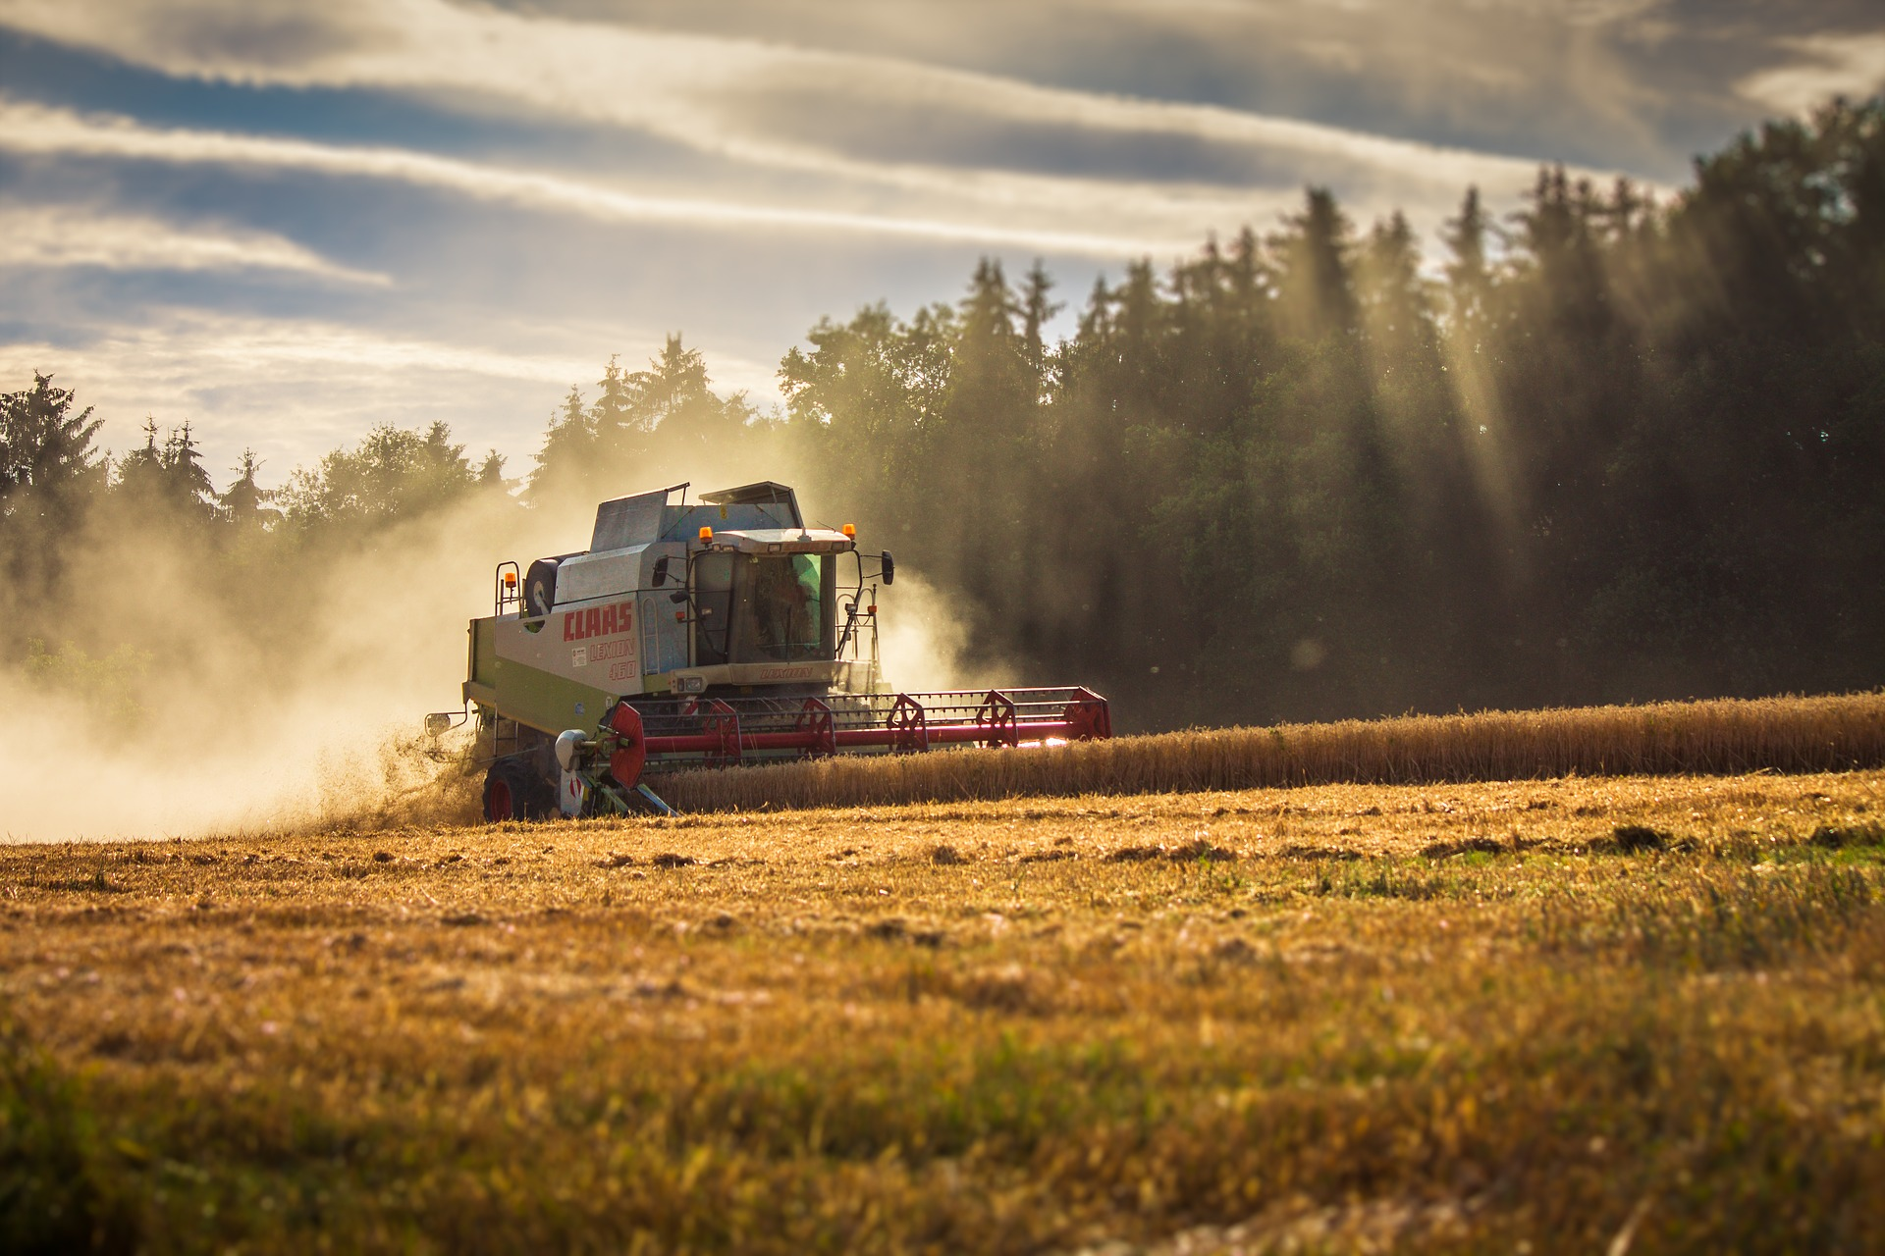
William the wheat farmer
My job is to grow the wheat and then harvest it when the time is right.

