A world with flour

1. Write down a list of the food you had yesterday.

Make a note of the food that contained flour.

Meal occasion | Food eaten | Which foods contained flour?

Breakfast

Lunch

Dinner

Snacks

Is this what you expected? Were there any surprises?

2. For each meal below, describe the use of flour.

Recipe

Fish fingers, chips and beans

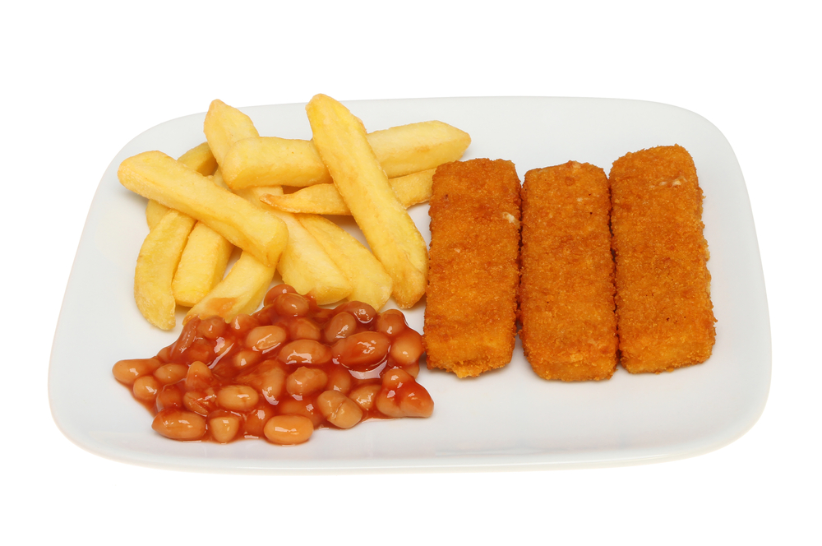

Spaghetti Bolognaise

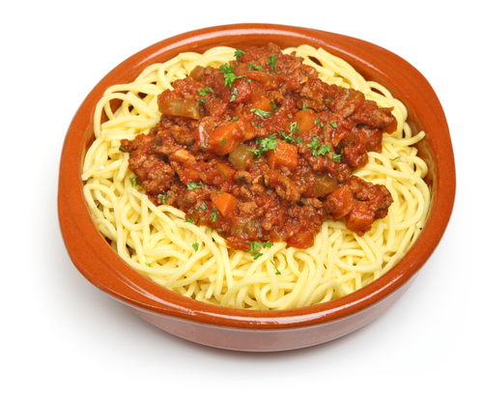

Lasagne

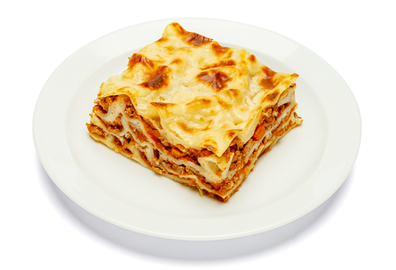

Roast beef, veg, potatoes, Yorkshire puddings, stuffing and gravy 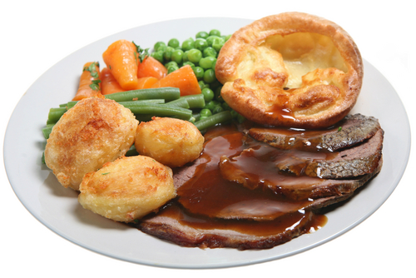

Cheese, ham and salad sandwich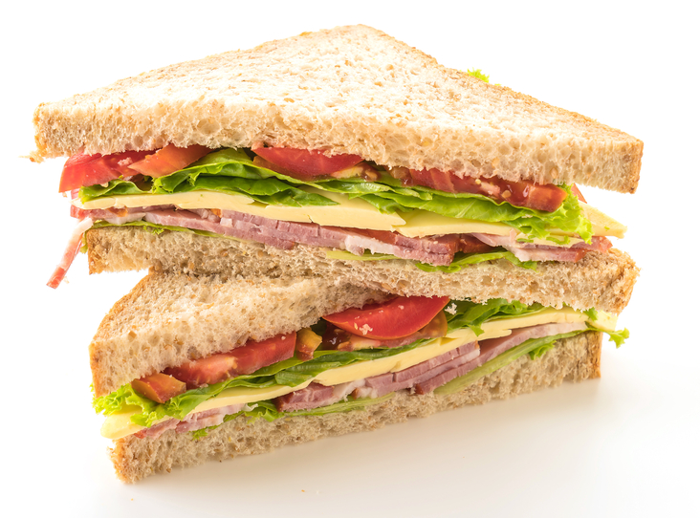

3. Extension

Create a poster entitled ‘A world without flour’.

