Be a baker!

Be a baker and create a new bread roll.
Sketch your bread roll below – considering:
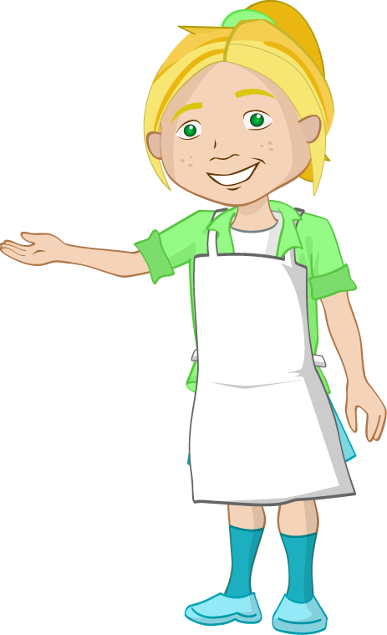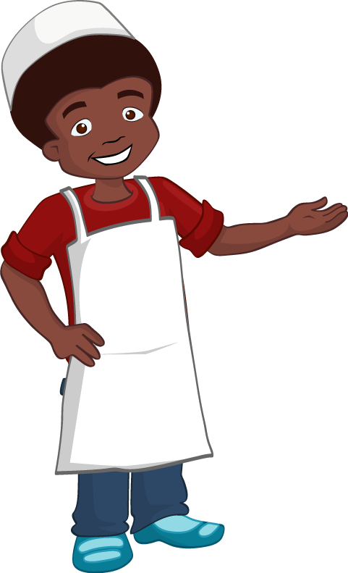
Toppings
Fillings
Shape
Other ingredients
Flour type

Write the recipe for your bread rolls – do they have a special name?

Make your bread rolls – work safely and hygienically.

Evaluate your bread rolls – consider colour, aroma, taste and texture.

