Lamb or beef samosas

Ingredients
Complexity: medium-high
1 onion
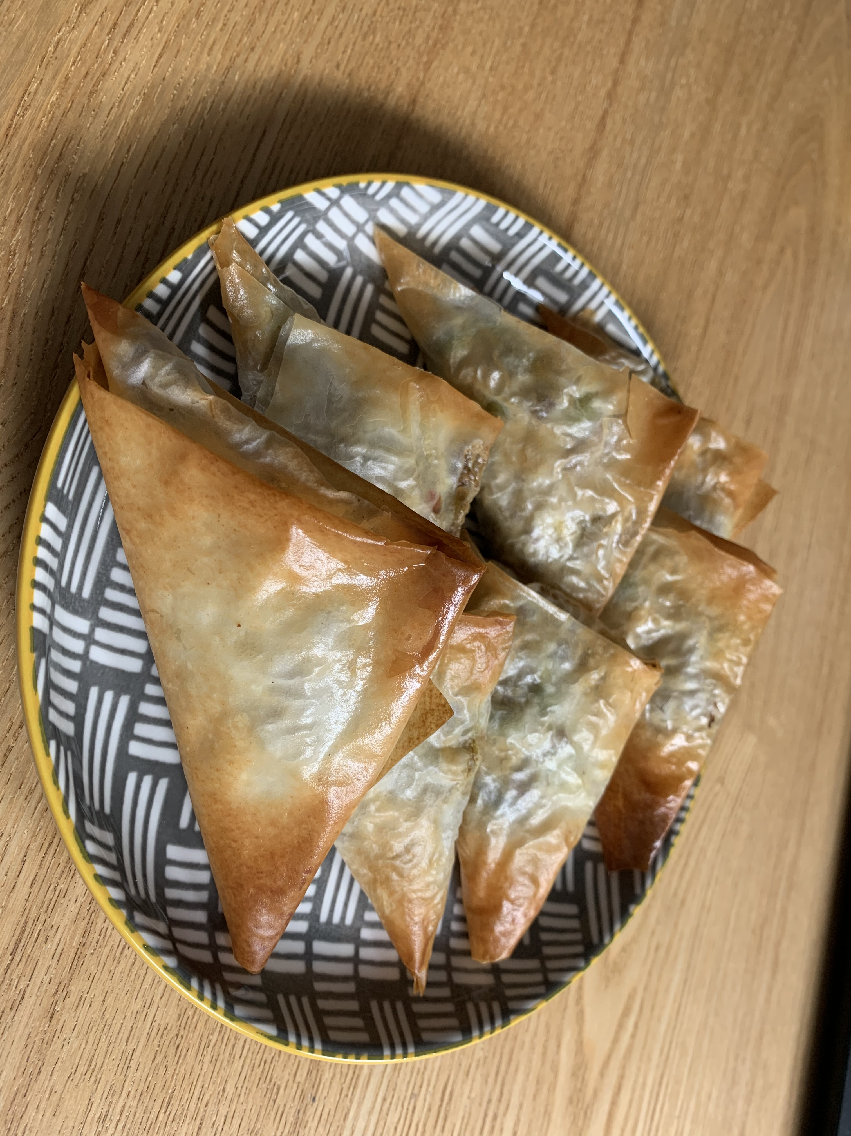
½ chilli (red or green)
Spray oil
125g lamb or beef mince
1 x 5ml spoon curry powder
60g peas (frozen)
2-3 x 15ml spoon water
4 x sheets Filo pastry
Oil (for brushing)

Equipment
Baking tray, chopping board, knife, weighing scale, frying pan, measuring spoons, pastry brush, oven gloves.

Method
- Preheat the oven to 200˚C or gas mark 6.
- Line or grease a baking tray.
- Prepare the vegetables:
  - peel and chop the onion;
  - de-seed and chop the chilli.
- Fry the onion and chilli, with some spray oil, in a frying pan for 3-4 minutes.
- Stir in the meat, ensuring no lumps, and cook until brown and there is no pink showing.
- Stir in the curry powder, peas and water.
- Allow the mixture to simmer for 5-8 minutes, then allow to cool.
- Cut the filo pastry sheets in half (lengthways).
- Take 1 sheet and brush its edges with oil.
- Place a 1 x15ml spoon of the mixture in the bottom left-hand corner.
- Fold the bottom right-hand corner over the mixture to form a triangle.
- Fold the bottom left corner up towards the top edge to create another triangle.
- Repeat this process until all of the pastry has been folded and you have a triangular parcel.
- Repeat the process with the remaining filo pastry and filling.
- Place the samosas on a baking tray and brush with a little oil.
- Bake in the oven for 10-12 minutes, or until golden-brown and crisp.
Top tips
- Use a fork to secure the chilli on the chopping board.
- Try frozen chopped onion or leeks.
- Additional and/or alternative vegetables could be added, to make the mixture go further.

Food skills
- Weigh.
- Measure.
- Peel.
- Cut and chop.
- Fry.
- Form and shape.
- Bake.

