

Bread Teachers’ Guide

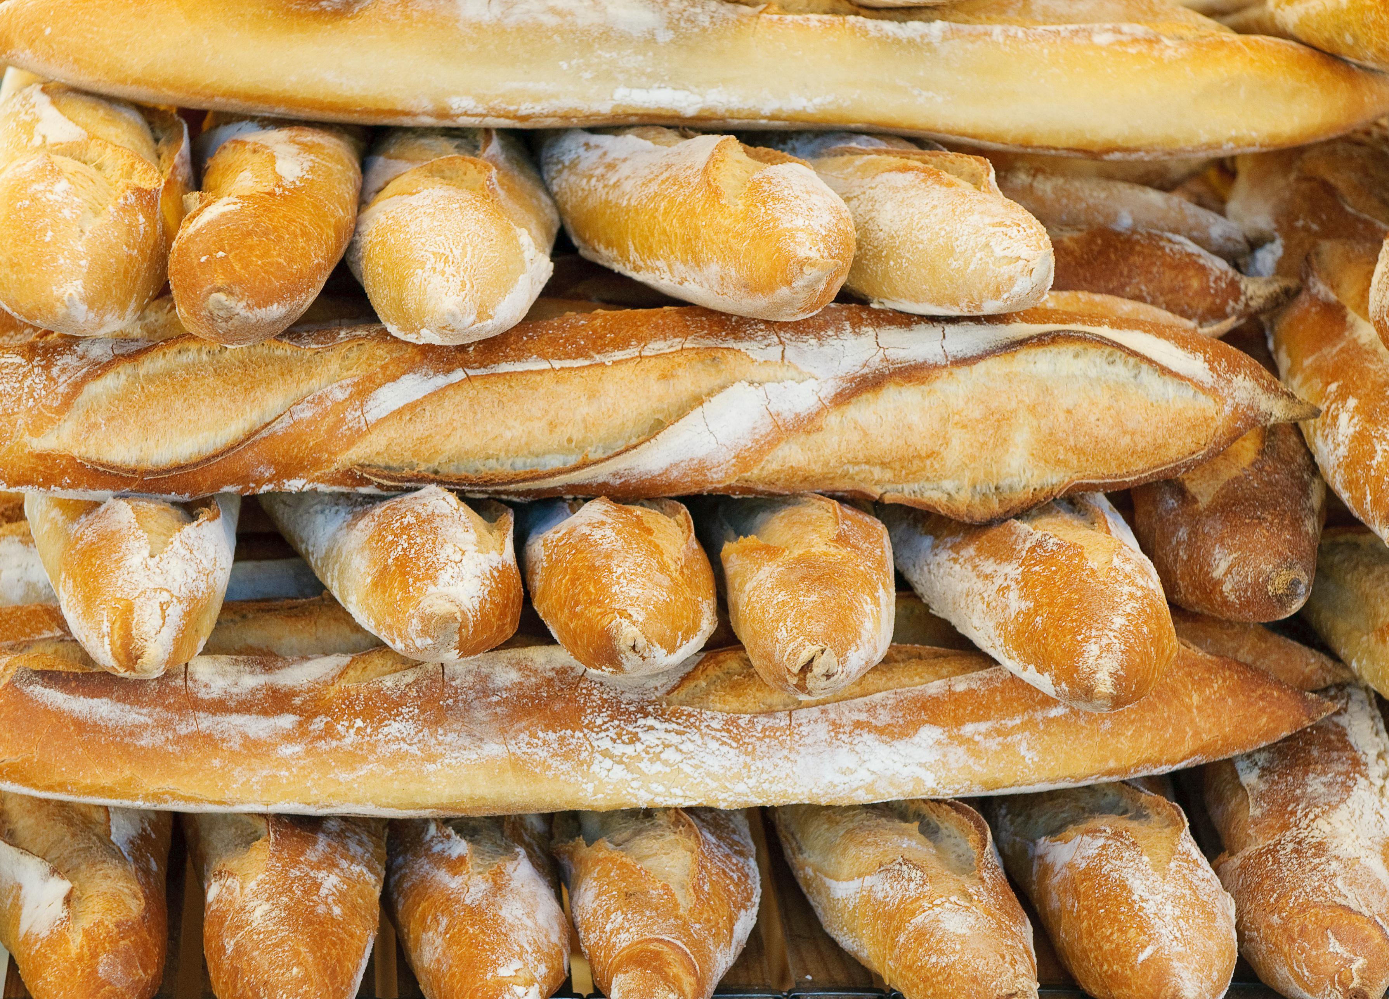
Welcome
This bread activity pack has been designed to support the teaching and learning around ‘bread’, its history, production and uses. Bread is a staple food that is eaten throughout the world and is used in schools as a context for learning.

Pages 3-5 provide background information to the teacher.

Pages 6 to 8 gives details on the resources, with activity ideas, to bring teaching about bread to life in the classroom.

Contents

Background information
The history of bread making | 3
Flour and bread consumption | 4
Bread facts | 5
Bread types | 6
Milling: facts and figures | 7

Classroom activities and resources
- History | 8
- A world without flour | 7
- Basic bread making | 8
- Uses of dough for other dishes | 8
- Super sandwich session | 8
- Be a baker challenge | 8
- Let’s get cooking! | 8
- Explore wheat | 8

The history of bread making
Bread is one of the most highly consumed foods in the UK with nearly 11 million loaves sold each day. However, bread has not always been available in the way in which it is now and there are a number of key steps, and people, that are important in helping produce bread from the raw ingredients.

In modern day bread making, milling wheat to make flour is an important part of the bread making process. The basic principles of milling were incorporated around three thousand years ago, when two flat, circular stones were stacked on top of one another and used to grind the grain. One of the defining characteristics of modern bread is the use of yeast to help it rise. However, whilst this method may seem modern, there is evidence of making bread using yeast that dates back to the ancient Egyptians in around 300BC.

The way bread is made has not always been the same. In the traditional process, although the same basic ingredients are used, there was a longer and slower fermentation process.
This meant that traditional bread making was a slow process and would not be able to keep up with the modern demand for bread.

Arguably the largest change to the bread making process was the invention of the Chorleywood bread process, which was developed in 1961. This process differed from previous processes in the speed it took to complete. Changes in the mixing speed meant that the fermentation process could be reduced to just one hour and the overall process was less than four hours. This meant that larger scale bread production was possible and there was a reduced cost of production. It also meant that bread could be produced with a longer shelf life.
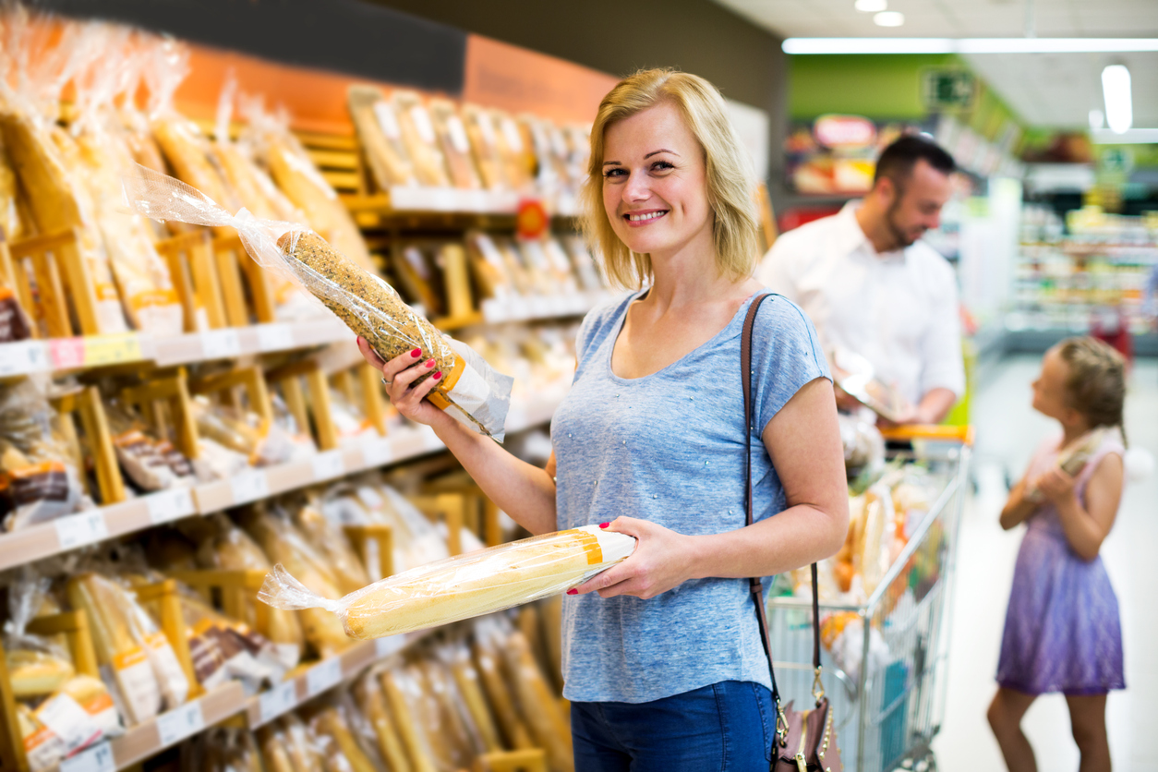
Flour and bread consumption
How much flour is consumed in the UK?
- UK flour consumption was 59kg per person per year in 2018/19.
Where does flour end up?
- About 60% of flour produced in the UK is used in the manufacture of bread products, with the remaining 40% being used in a huge diversity of food products.
How much bread does the UK eat?
- Bread is bought by 99.8% of British households, and the equivalent of nearly 11 million loaves are sold each day.
- Approximately 60-70% of the bread we eat is white and sandwiches are thought to account for 50% of overall bread consumption.
- Average bread purchases are the equivalent of 60.3 loaves per person per year.
- According to the government’s National Diet and Nutrition Survey, median bread consumption per person is approximately 90 grams per day, higher for men (113g) than for women (76g).
- Large bakeries, which produce wrapped and sliced bread, account for 85% of UK bread production. In store bakeries within supermarkets produce about 12% of bread, with the remainder accounted for by high street bakeries.

Bread facts
- Over 200 different kinds of bread are produced in the UK – from butter rich brioche and crisp baguettes to farmhouse loaves and focaccia, soft ciabatta and crumpets to chapattis and flaky croissants. This diversity is only possible because of the vast range and quality of British flour available.
- Sandwiches account for 50% of bread consumption; whether bought or made-at-home.
- Despite being a staple food in the UK for centuries, bread consumption has fallen steadily over the last few decades. Average consumption now equates to only around 2-3 slices of bread per person a day.

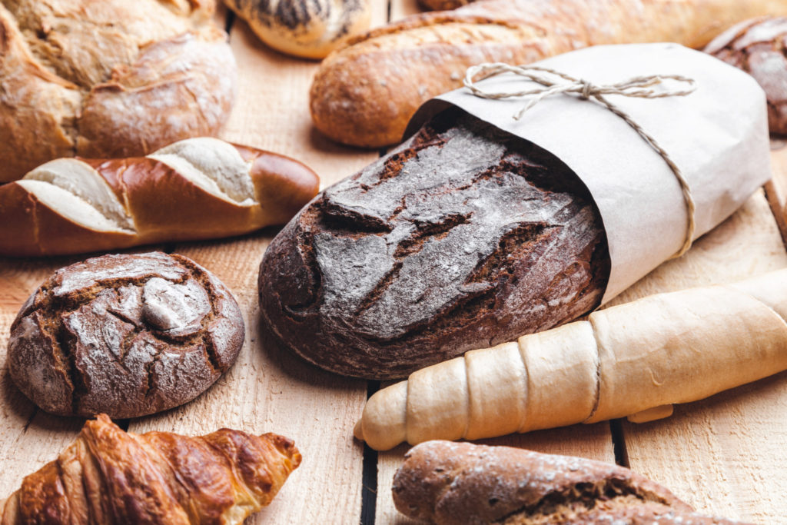
Types of bread
- Bara Brith – Fruited bread from Wales of which there are many varieties, some made with yeast and others baking powder. Traditionally eaten sliced and buttered.
- Barrel – Usually made with a milk bread dough, baked in a ridged mould. Also known as a pistol.
- Batch – Loaf baked in a batch with others, rather than separately, wholemeal.
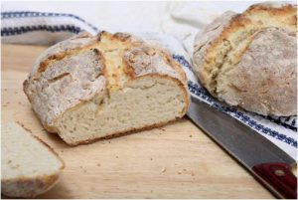
- Bloomer – Thick, long, white loaf, lightly cut across the top so that the cuts open out or ‘bloom’ to give a crisp crust. Sometimes sprinkled with poppy seeds.
- Buttery Rowies – Traditional Aberdeen butter yeast rolls. Shaped in a round or oval with a crisp crust and light flaky texture.
- Cob – Round smooth crusted loaf often topped with cracked wheat.
- Coburg – Round, crusty white loaf with a deeply cut cross on the top.
- Cornish Splits – Sweet, light yeasted buns enriched with butter and milk. Also called Devonshire splits. Often dusted with icing sugar and traditionally eaten filled with jam and clotted cream.
- Cottage – White loaf made from two round pieces of dough. One (smaller than the other) is secured on top of the larger piece. Often dusted with flour before baking.
- Farmhouse – White loaf baked in a special tin and cut lengthwise along the top, often dusted with flour.
- Plait – A special shape, usually plaited with three strands of white dough, sometimes enriched with eggs or milk.
- Rolls – Many different varieties, shapes and sizes ranging from crusty white rolls to soft wholemeal baps.
- Sandwich – Large flat-topped loaf baked in a lidded square tin.
- Sliced wrapped – With many different varieties including white, brown and wholemeal, the sliced wrapped loaf is a convenient bread which makes perfect toast and sandwiches.
- Soda Bread – Flat, round, heavy loaf usually marked into quarters and risen with baking powder, not yeast. Soda Bread comes originally from Ireland.
- Stottie – A flat round large bap from the North East of England. The Geordie stottie has a fluffy texture and was often traditionally eaten filled with bacon and pease pudding.
- Tin – Loaf baked in a rectangular open tin.
Milling: facts and figures

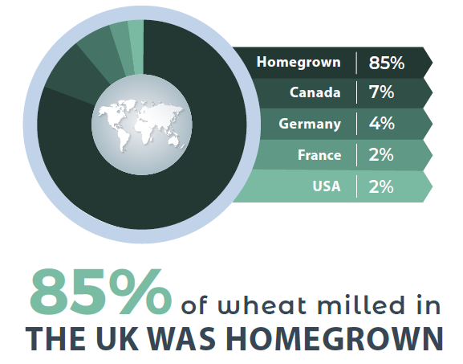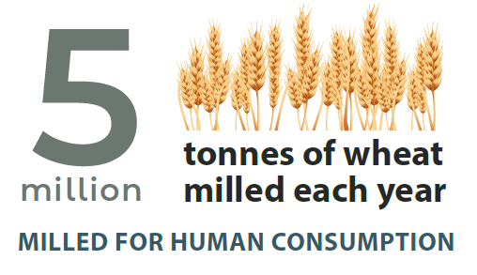

Type of flour milled: This shows the use of the different types of flour milled
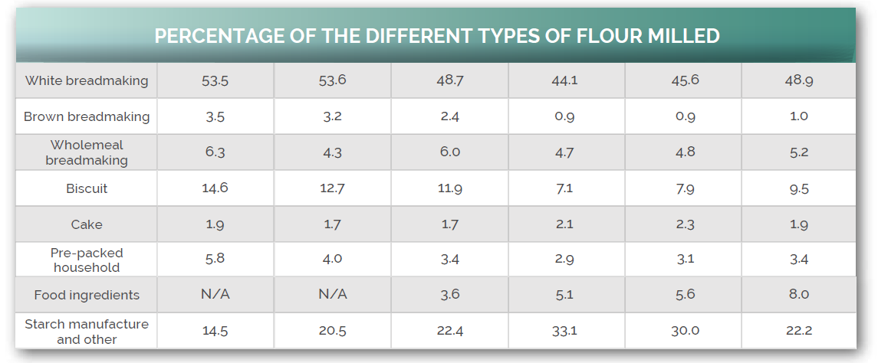

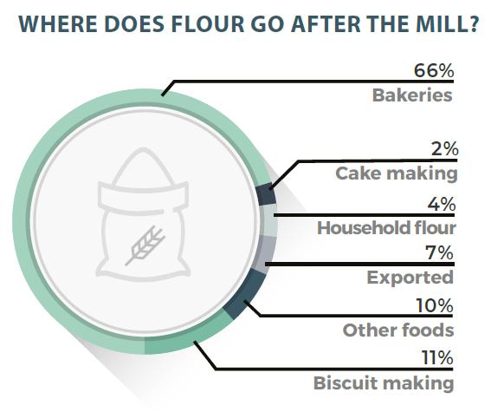
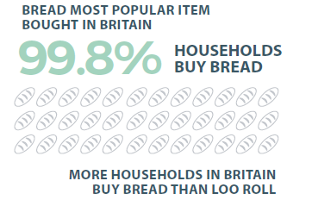
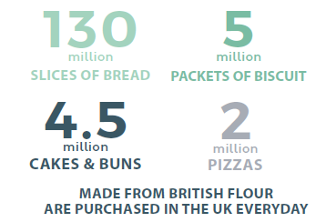
Classroom activities and resources

A range of resources have been created to support the teaching of harvest and harvest festival. The resources can be used individually, or used together to support more detailed topic work.

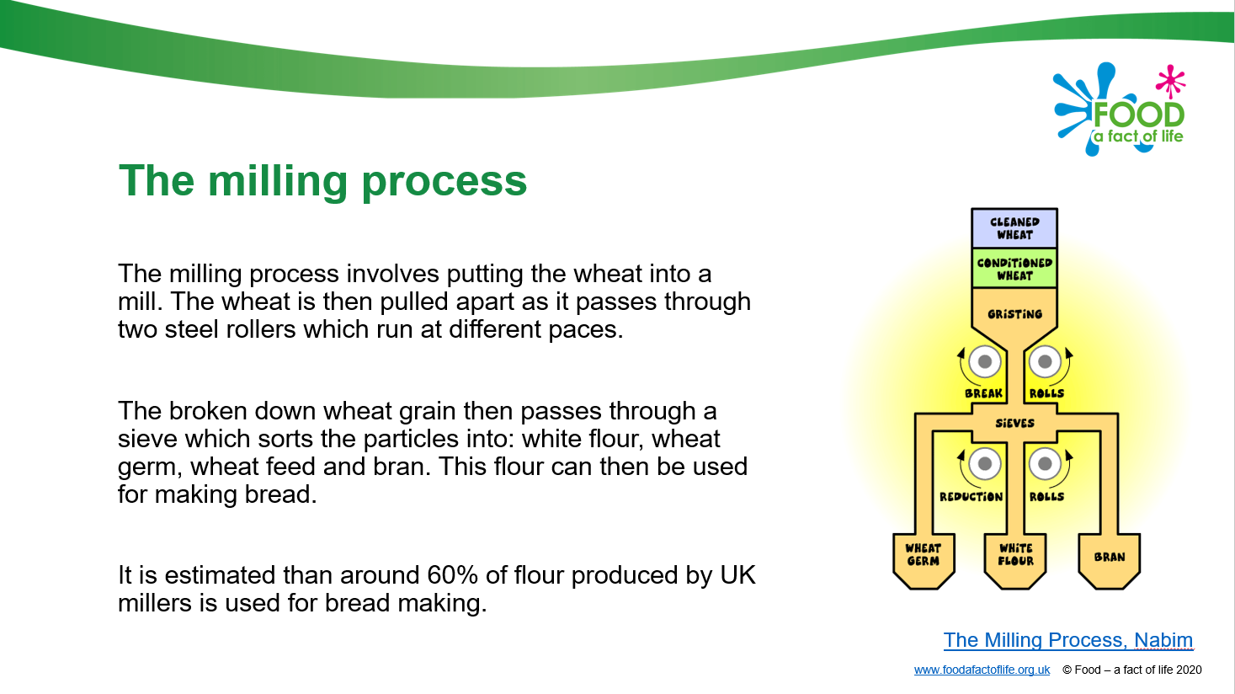
1. History

This section looks at the history, traditions and modern production.

Resources:
- The history of bread presentation
- The history of bread cards
- Bread production presentation
- Bread jobs cards

2. A world without flour

This section looks at the dishes and recipes that could not be made without flour.

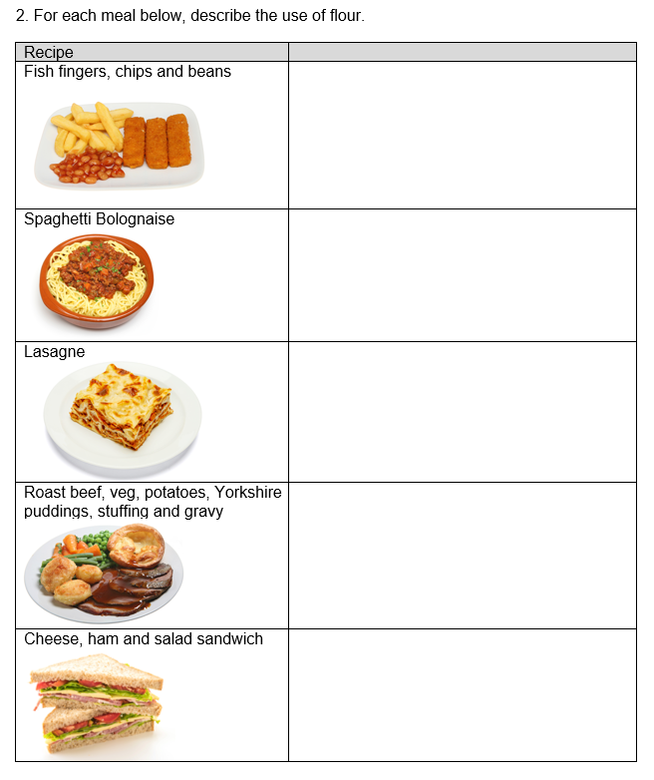
Resources:
- World without… worksheet
- World without flour worksheet

Some dishes and recipes that use flour include …

Biscuits

Bread

Breadcrumbs

Brioche

Cakes

Calzone

Cheesecake

Cheese sauce (roux/all-in-one)

Cookies

Crackers

Croissants / Danish pastries

Crumble

Crumpets

Fish fingers

Gnocchi

Gravy
Write the recipe for your bread rolls – do they have a special name?

Make your bread rolls – work safely and hygienically.

Evaluate your bread rolls – colour, aroma, taste and texture.

Lasagne

Muffins

Pancakes and waffles

Pastry – pies, sausage rolls, quiche

Pikelets

Pizza

Pretzels

Sandwich

Sausage

Scones

Soups (flour used to thicken)

Spaghetti

Stuffing

Yorkshire pudding/toad in the hole

3. Basic bread making

This section looks at the types of bread and the basic bread making steps.

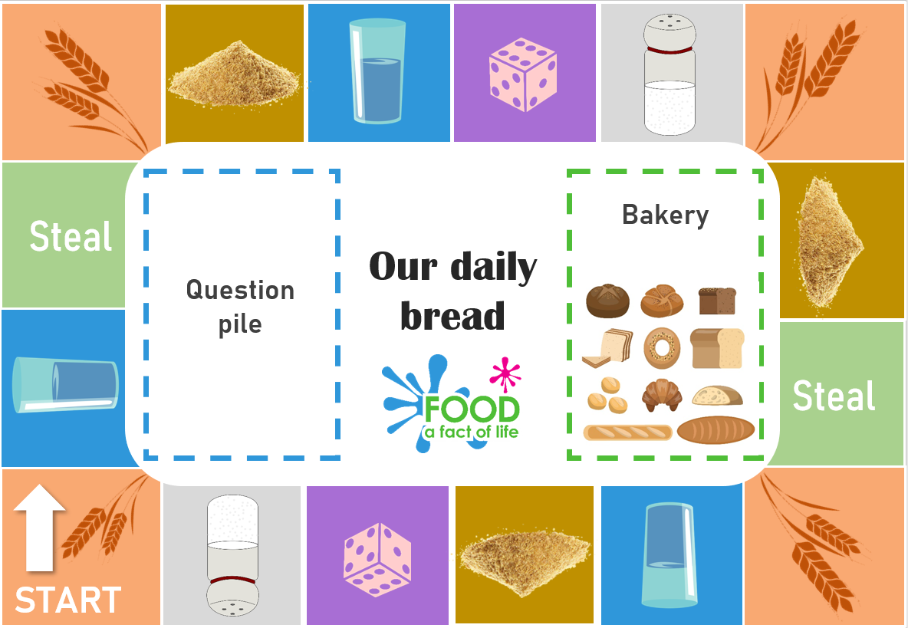
Resources:
- Baking bread steps presentation
- Bread step by step cards
- Our daily bread game
- Bread traditions around the world
- Different types of flour
- What bread am I? cards
- What is in my bread? Worksheet

Recipes:
- Bread recipe
- Naan bread
- Soda bread

4. Uses of dough for other dishes

This section looks at the uses of dough for other dishes.

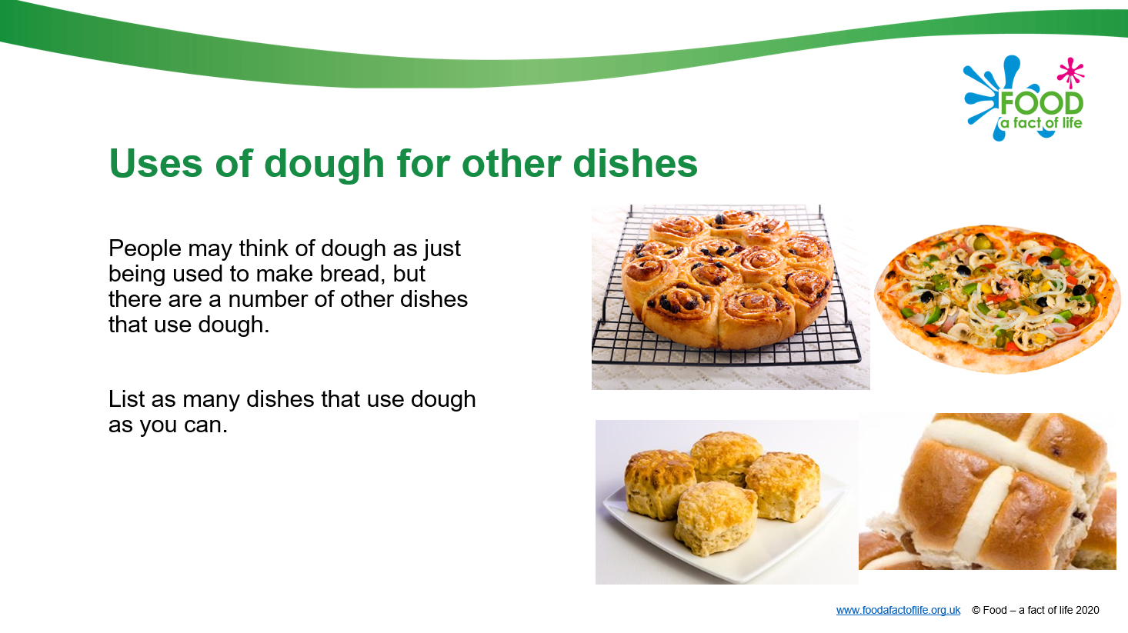
Resources:
- Using dough cards
- Designing a dough dish worksheet
- Uses of dough for other dishes presentation

Recipes:
- Chelsea buns
- Hot cross buns
- Pizza wheels
- Pizza
- Scone based pizza

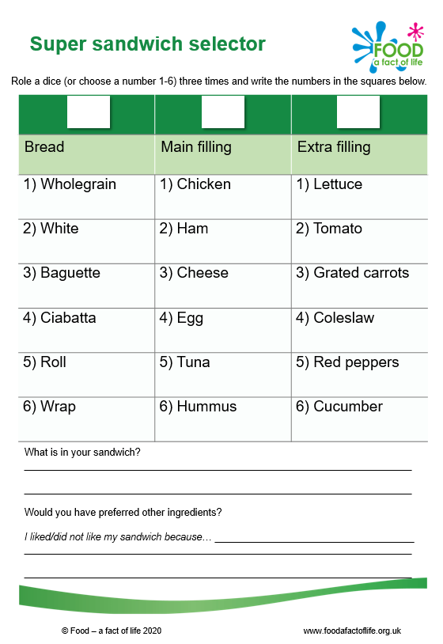

5. Super sandwich session

This section looks at choosing ingredients for a sandwich.

Resources:
- Super sandwich session presentation
- Super sandwich (primary)
- Super sandwich (secondary)
- Super sandwich selector
- Costing your own sandwich worksheet
- What makes a good sandwich worksheet

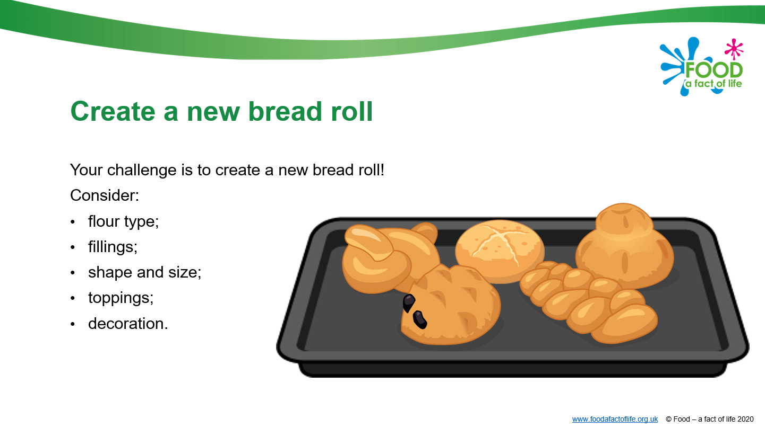
6. Be a baker challenge

This section looks at being a baker.

Resources:
- Be a baker challenge presentation
- Be a baker worksheet
- Jobs of a baker worksheet
- You are the baker worksheet

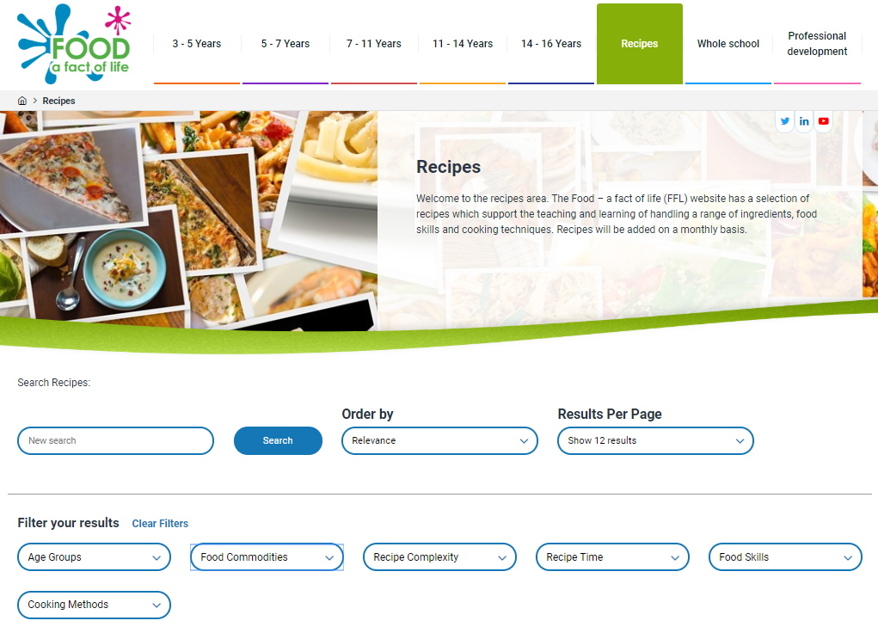
7) Let’s get cooking!

There’s a huge range of recipes on the Food – a fact of life website - https://www.foodafactoflife.org.uk/recipes/.

Recipes can be filtered by age, complexity, time, food skill, cooking method (e.g. baking) and food commodity (e.g. cereals, like flour).

Organise cooking sessions for your pupils, demonstrating how fibre can be increased. For example, why not bake different types of bread?

Resources to support learning around cooking are also available, including materials about different types of ingredients and equipment, as well as food hygiene and safety:
- 5-7 Years
- 7-11 Years
- 11-14 Years
- 14-16 Years

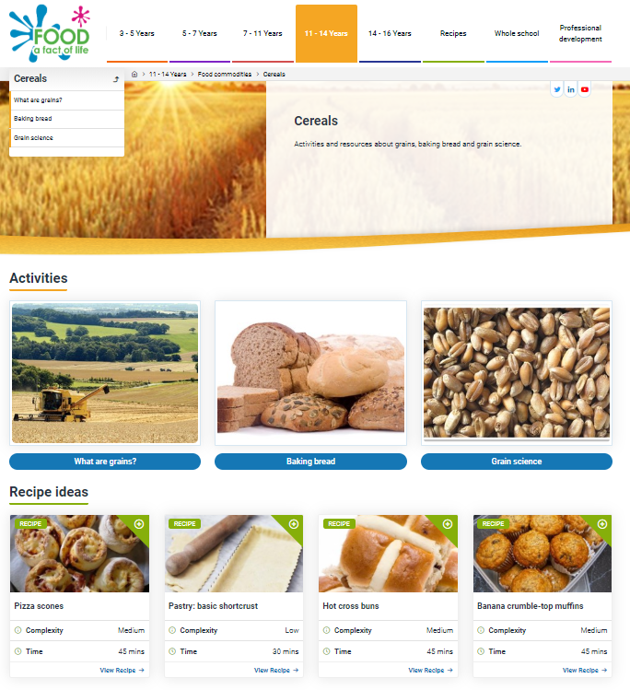
8) Explore wheat

Explore wheat production, milling and processing using the resources available on Food – a fact of life. For example, you could explore where wheat comes from to extend learning:
- 5-7 Years
- 7-11 Years
- 11-14 Years
- 14-16 Years

