What’s the weight?

What is the weight of each of these fish? Label the weighing scales.
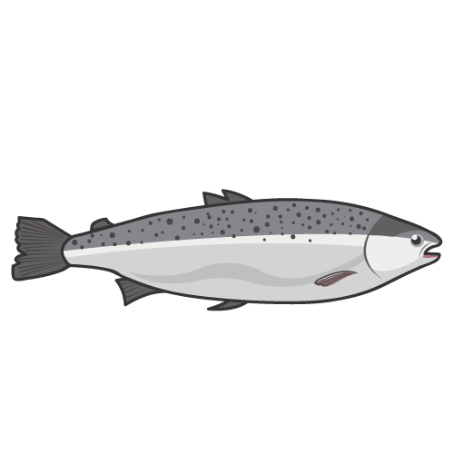
2.5 Kg
3.5 Kg
750g
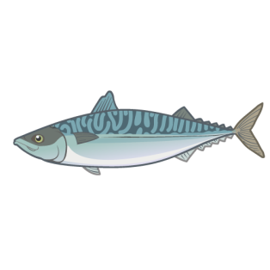
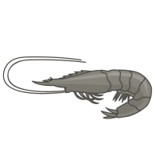
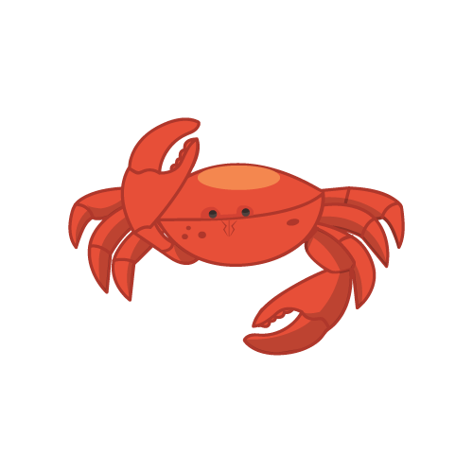
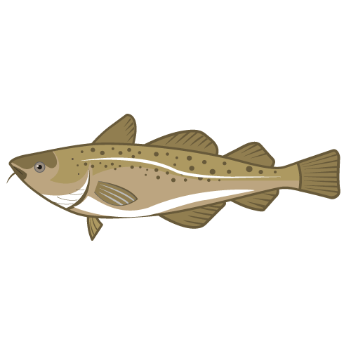
2000g
1 Kg
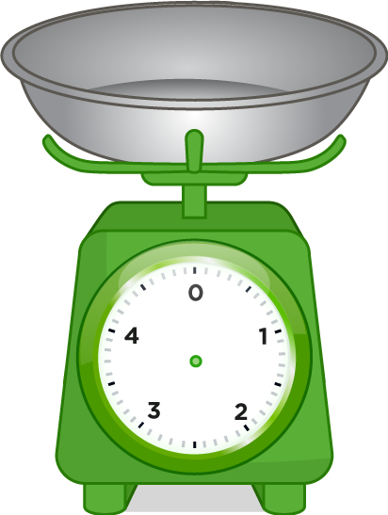

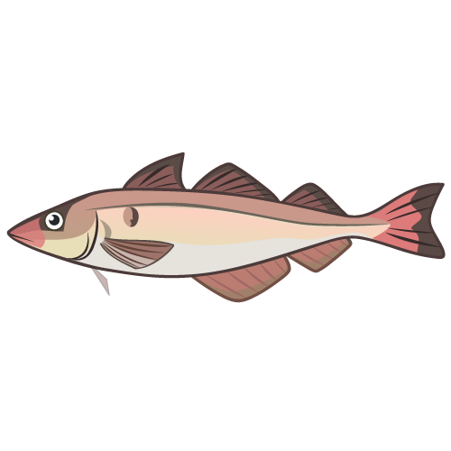


What weight do these weighing scales show?

Using four of the weights above, find objects in your classroom which are of an equivalent weight.
Weight:

_____________

Object/s:

_______________
Weight:

_____________

Object/s:

_______________
Weight:

_____________

Object/s:

_______________
Weight:

_____________

Object/s:

_______________

