Favourite fish dish survey
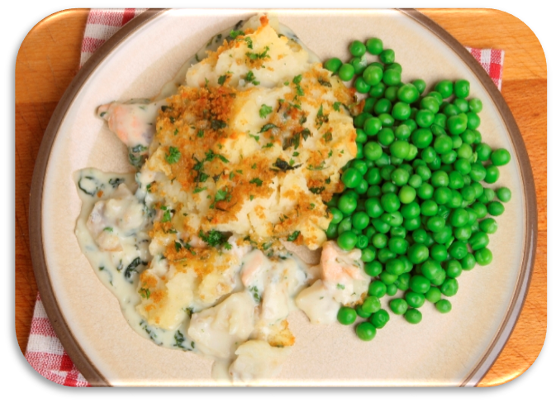
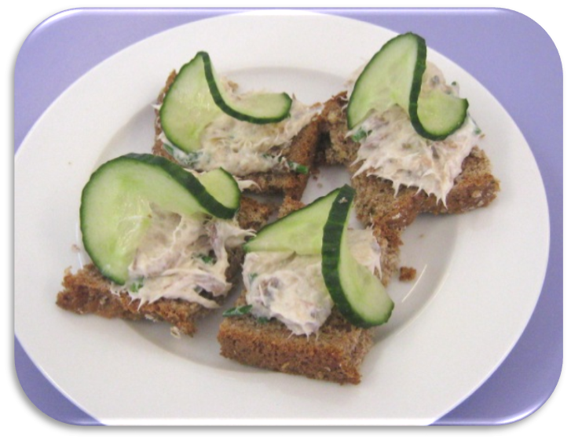
Find out which fish dish is the most popular.
15
14
13
12
11
10
9
8
7
6
5
4
3
2
1
 | Fish fingers | Paella | Prawn stir-fry | Fish cake | Fish pie | Mackerel pâté on toast
