Fascinating facts about wheat!
Wheat is one of the most important cereal crops grown in the UK. Its main use is to make flour that can be used in the production of bread, breakfast cereals, pasta, cakes, biscuits and many other foods. Here are some amazing facts about wheat:

- In the UK alone, the land used for wheat is around 1.9 million hectares – that’s an area nearly the size of Wales!
- 5 million tonnes of wheat is processed by UK flour mills each year.
- 85% of wheat used by UK flour mills is grown in the UK.
- There are five main species of wheat grown in the UK; each one has properties that make them suitable for different uses. For example, durum wheat is mostly used to make pasta.
- The modern ‘common wheat’ has been cross-bred from three different species, giving it desirable properties from each one.
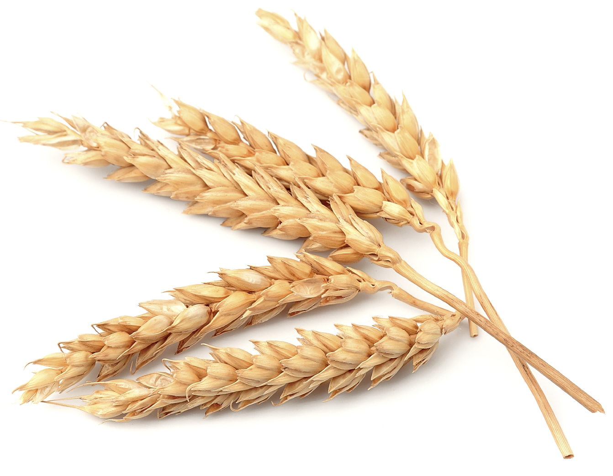
Quiz (answers at bottom of page):

- Wheat is the second most produced crop in the world. Which grain do you think is the only one that is produced in higher amounts?
- True or false? Pasta is normally made from common wheat.
- True or false? 85% of wheat milled for flour in the UK is home grown.

Wheat varieties

Wheat species | Percentage of world production | Main uses
Common wheat  (Triticum aestivum) | ~95% | Bread, cakes, biscuits, breakfast cereals. Also the main variety sold for home use as flour.
Durum wheat  (Triticum durum) | ~5% | Pasta, as well as often being used for couscous and bulgur. Occasionally used in bread making.
Emmer wheat  (Triticum dicoccum)  Einkorn wheat  (Triticum monococcum)  Spelt  (Triticum spelta) | <1% | These varieties are rarely grown in the UK, but are occasionally used for variety in some products. Some are popular in other countries; for example spelt bread may be found more widely in Poland. In countries with poor soils or difficult climates, these varieties can sometimes grow better than common wheat.
- Rice 2. False 3. True

