Harvest Haikus

Haikus are short, three line poems. The first and last lines usually have five syllables and the second line has seven syllables.
Write a Haiku for each of the topics on this page. An example has been given for you.

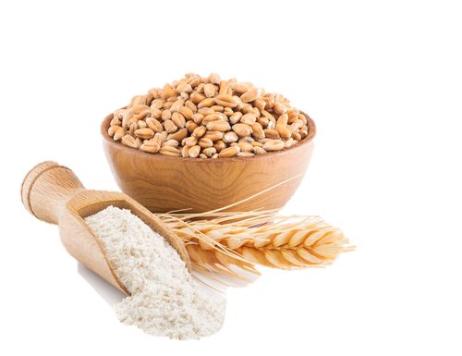
Example:
Grains being milled into flour
_____________________________________________________________
_____________________________________________________________
_____________________________________________________________
Across the wheat fields
Wherein golden sheaves abound;
The autumn breeze blows.

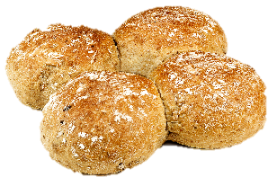
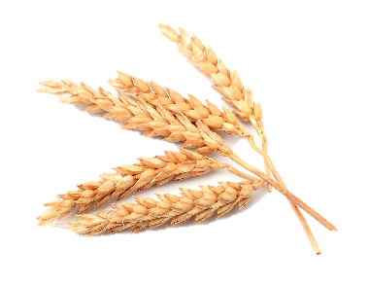

Wheat being harvested
_____________________________________________________________
_____________________________________________________________
_____________________________________________________________
_____________________________________________________________
_____________________________________________________________
_____________________________________________________________
Farmers working in the fields
Flour being made into bread
_____________________________________________________________
_____________________________________________________________
_____________________________________________________________

