Grow your own wheat!

Growing wheat in school probably won’t get you plants that can produce grains
to make bread, but you can still plant wheat seeds and watch them grow into young wheat plants. The first step is to make the seeds germinate by growing them on damp kitchen roll. Then they can be planted to allow the roots to grow.

Equipment:
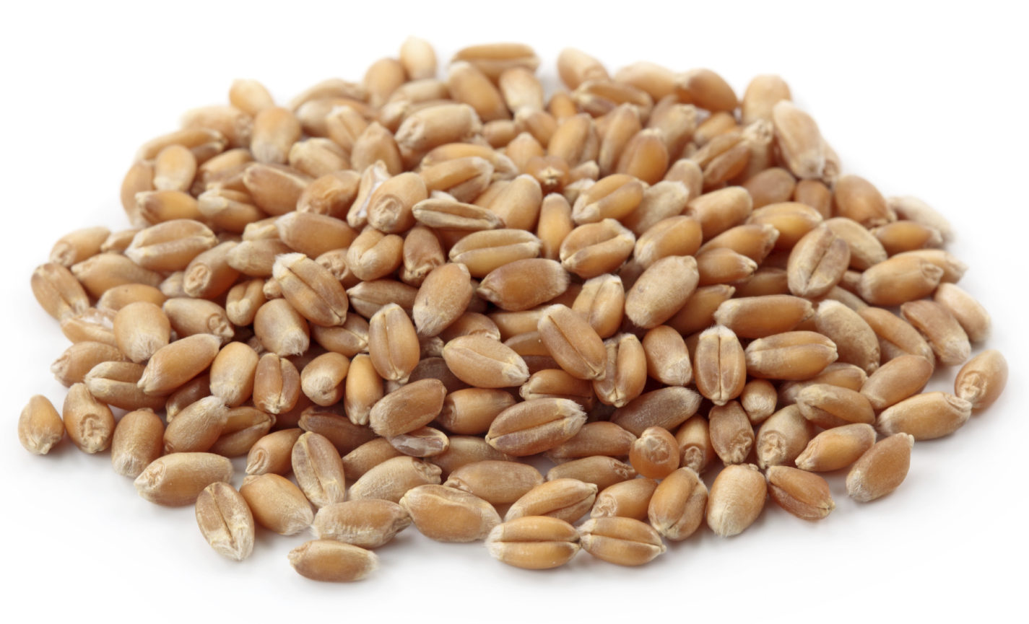
- Kitchen roll
- Shallow plastic tray
- Small jug
- 24-30 wheat seeds
- Plastic cup or small plant pot
- Ball of tac
- Pen
- Plant compost (any standard type)
- Sprouting wheat grains
- Small trowel or old spoon (no longer used for eating)
- Tray or bowl to catch drained water

Germinating the seeds:

- Place sheets of kitchen roll in the plastic tray to cover the entire tray.
- Spread the wheat seeds out over the kitchen roll.
- Soak the kitchen roll by pouring in water from the jug. On this first watering, make sure that the seeds are just covered with water.
- Keep the kitchen roll damp by watering the kitchen towel every couple of days (do not let the roll go dry).
- After a few days, the seeds will germinate and you will see roots and shoots begin to form.
- After 6-8 days, the germinated seeds should be ready to plant in soil.

Planting the seeds:

- Place the ball of tac on the tray and stick the cup or plant pot on top of it. If using a plastic cup, make sure to poke holes in the base to allow water to flow through.
- Fill the cup or plant pot with compost until around 3cm from the top.
- Water until damp.
- Place 6 seeds evenly on the surface of the compost.
- Cover the seeds with more compost until the pot or cup is nearly full.
- Water until damp.
- Place the pot or cup in a warm, sunny area (e.g. a window sill).
- Water the compost every few days to keep it damp.
- After around a week, shoots should begin to emerge. The wheat will grow for around 30 days, producing more leaves. However they will often fall over if they grow much beyond this point.

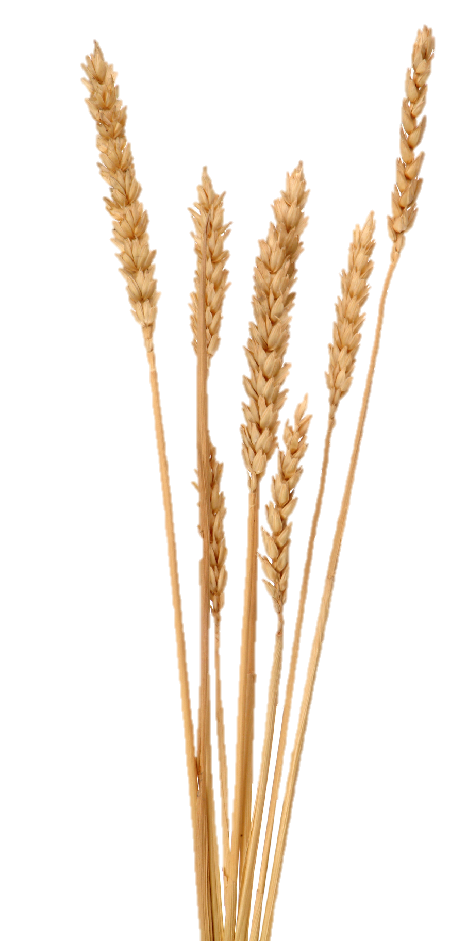
Extension – The conditions for growth

As an extension activity, you can try growing wheat seeds in various different conditions. For example, you may wish to set up wheat in some of the following ways:

- On a warm, sunny windowsill and watered regularly
- On a warm, sunny windowsill with no water
- In a dark cupboard and watered regularly
- In a dark cupboard with no water
- In a cold, dark place (e.g. the fridge)

You can then observe how the various wheat plants grow differently (or don’t grow at all). Use the table below to record the appearance of your wheat plants over a period of three weeks.

Conditions | 1 week | 2 weeks | 3 weeks
Warm, sunny, water

Warm, sunny, no water

Warm, dark, water

Warm, dark, no water

Cold, dark, water

Which wheat plants had sprouted after 2 weeks?
______________________________________________________________________

Name the conditions that resulted in the tallest plant at 3 weeks.
______________________________________________________________________

Explain why you think this plant grew tallest.
______________________________________________________________________
______________________________________________________________________

