Make a harvest loaf
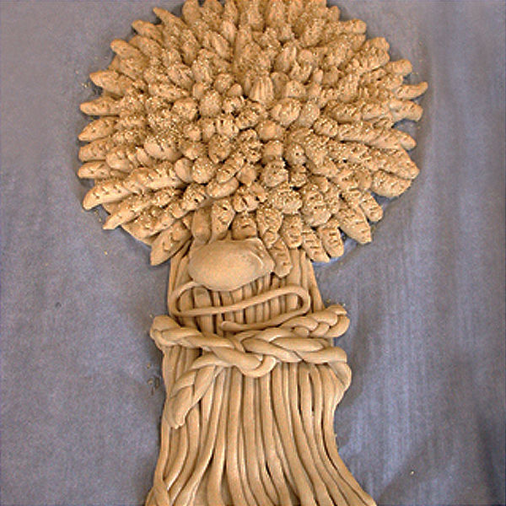
This ornate harvest loaf can be made to be eaten, or to be kept as a harvest decoration.

Ingredients
500g white bread flour
1 x 5ml spoon dried yeast
½ x 5ml spoon salt
300ml warm water
1 egg

Equipment
Weighing scales, measuring jug, measuring spoons, large baking tray.

Method
- Line a large baking tray with parchment and pre-heat the oven to 200ºC (gas 6).
- Put the flour, yeast, sugar and salt into a large bowl and blend them together.
- Stir in the water.
- Using your hands, gather everything together into a doughy mass.
- Knead the dough until it feels smooth and pliable.
- Divide the dough into three pieces.
- Take one third of the dough and roll it into a rectangle, the size of your baking tray.
- Cut into a large mushroom shape, place it onto the prepared tray, and brush all over with water. Gather together dough off-cuts and roll them into a ball for use later.
- Cut the second piece of dough into 30 pieces and roll each out thinly.
- Lay these onto the 'stalk' of your mushroom shape to make the stalks of the wheatsheaf.
- Cut the third piece of dough into three pieces, roll each into a long thin cylinder then cut each one into twenty small lengths. These will form the ears of wheat.
- Working inwards from the outer edge, quickly press the end of each small length onto the round part of the mushroom shape.
- Using scissors make several snips into the end of each small dough length to create the impression of grains in an ear of wheat.
- Divide the off-cut dough into three pieces, roll each into a 25cm length and plait them together.
- Brush the middle of the wheat stalks with water and lay the plait across them to create the impression of string around the sheaf. Use any remaining dough to make a dough mouse.
- Beat the egg well and brush it all over the dough.
- Bake immediately for 25 minutes.
- To keep the sheaf as a decoration, lower the temperature to 130ºC and bake for a further 5 hours.
- To keep this as a decoration for a longer period of time, then brush the dough with varnish.

