Healthy eating and physical activity
- People around the world choose and combine different food to make meals and snacks. The total amount and range of food and drinks consumed is called the diet.
- A healthy diet is made from a variety of different food and drinks, as depicted in The Eatwell Guide.
- Being active is important for health, making the body fitter and stronger.



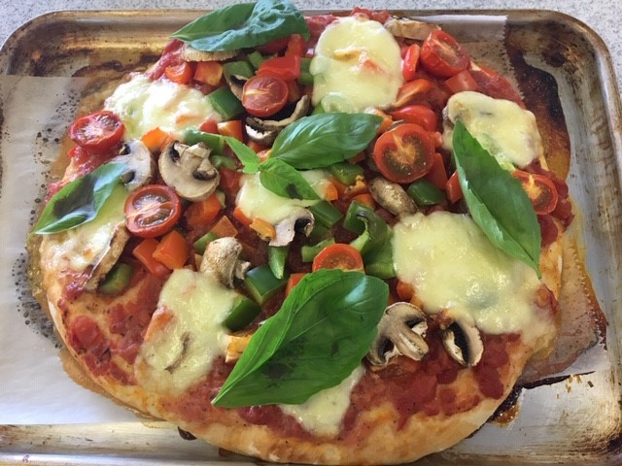
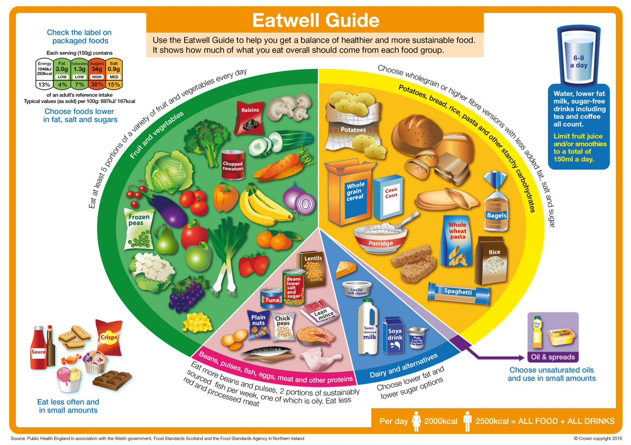
Task: Plan a menu for a day that applies the principles of The Eatwell Guide.

Being active is important for health.

Children should be active for 60 minutes a day.
Potatoes, bread, rice, pasta or other starchy carbohydrates
Eat a food from this group at every meal. Go for wholegrain varieties.

Dairy and alternatives
Have some of these foods every day, e.g. a pot of yogurt and a cheese sandwich.

Oils and spreads
Eat in small amounts.

Fruit and vegetables
Eat at least five portions every day.

Foods high fat, salt and sugar
This type of food is not needed to be healthy. If eaten, have less often and in small amounts.
Beans, pulses, fish, eggs, meat and other protein
Eat some foods every day.
Hydration
Water and lower fat milk are healthier drink choices.
A max of 150ml of juice or smoothie a day.

There are many different types of food from around the world.

People all around the world need a variety of food from different food groups to have a healthy diet.
To find out more, go to: https://bit.ly/2YSetUw

Vigorous activity includes:
- football;
- swimming.
Moderate activity includes:
- dancing;
- riding a bike.
Activity should make:
- you feel warmer;
- you breathe harder;
- your heart beat faster.

Cheese
Dairy and alternatives

Ham
Beans, pluses, fish, eggs, meat and other proteins

Tomato sauce
Fruit and vegetables
Base
Potatoes, bread, rice, pasta and other starchy carbohydrates
Meals and snacks can be sorted into The Eatwell Guide food groups.

The Eatwell Guide shows the proportions in which different types of foods are needed for a well-balanced and healthy diet.

The Eatwell Guide can be used to devise meals and snacks.
Dishes and meals eaten around the world often comprise similar food (or ingredients) combined in different ways.

