Executive Chef Lecturer

Gary Maclean, City of Glasgow College
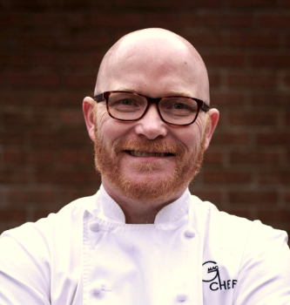

What qualifications do you have?
Higher National Diploma in Professional Cookery
Teaching Qualification in Further Education, Dundee University

What does your job involve?
My Role at college is very varied. I work as part of the Corporate Development team looking to expand the College reach locally and internationally, I also hold a voluntary position with the Scottish Government as Scotland’s National Chef

What, or who, inspired you to take your chosen career pathway?
I have had many completely different roles as a chef from Executive chef of huge companies and institutions to teaching.

What route did you take from leaving school to your current job?
I left School at the age of 15 I worked in a very good country house hotel, I then moved to a national 5 star hotel chain then on to 3 rosette fine dining restaurants. I then became head chef and started running multiple restaurants before moving on to teaching and then onto my role now.

What is the key knowledge, skills and experience needed for your job?
I think it’s about continued learning in this industry and the longer you are in Hospitality more and more doors get opened and your skills transfer into whatever your next adventure is going to be.

What is the best thing about your job?
I just love being a chef it has given me everything. At the moment I am in a crazy time of my career I have moved into doing lots of work all over the world. I now right books have my own TV show and represent my country at many competitions and events.

What questions are you often asked about your job?
The question I probably get asked the most is how to become a chef lecturer. My advice to that question is to get back to your old college and express an interest in teaching the easiest way is to start part time and learn how to do it, then wait until a full time post comes up.

What advice would you offer to someone interested in doing what you do?
The main advice is to work with talented people in good establishments. Do not chase money especially when you are young. Get qualified, qualifications become more important the older you get. Work hard and the most important advice is to dream big as the hospitality industry creates unbelievable opportunity’s that you don’t get in any other industry.

