Research Scientist

Sarah Kendall, ADAS
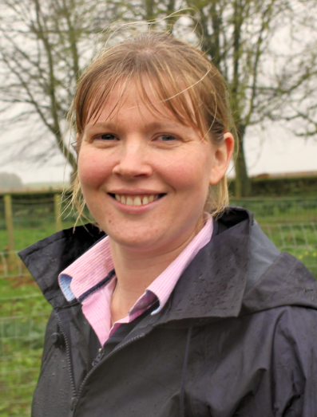

What qualifications do you have?
Biology degree, Durham University
PhD, Plant Molecular Biology, University of York

What does your job involve?
I work as a crop physiologist for an agricultural and environmental consultancy, whereby research in our group is focussed on improving crop yields in a sustainable manner. This includes research on optimising crop nutrition, understanding plant tolerance to pest damage, determining the benefits of precision farming technologies, and developing methodologies for field-scale research. An important aspect of my job is communicating research results to farmers and agronomists. Research in our group is funded by DEFRA, AHDB, AgChem companies, fertiliser companies and plant breeders.

What, or who, inspired you to take your chosen career pathway?
I was brought up on a mixed farm in East Yorkshire, and have always had a keen interest in agriculture, especially from a scientific angle. Following a degree in Biology, and then a PhD working on a model genetic plant called Arabidopsis, it was clear to me that although I wanted to develop a career path that had a scientific basis, I was much more interested in my research being accessible and useful for farmers and agronomists, rather than being too theoretical.

What route did you take from leaving school to your current job?
I went to Durham University and completed a Biology degree, followed by a
PhD in Plant Molecular Biology at University of York.

What is the key knowledge, skills and experience needed for your job?
Key understanding of plant physiology and good plant biology understanding.
Good grasp of agriculture and especially of arable systems.
Excellent communication skills across a range of mediums – presentations, report writing etc.
Project management – managing deliverables, project finances, risk, managing a team.

What is the best thing about your job?
I work on a range of projects which cover different aspects of crop production and this keeps things interesting. My job involves a mix of project management with fundamental science and I enjoy this mix. The best thing about my job is the fact that my research contributes to helping farmers to improve, whether that is in increasing yields or quality or becoming more sustainable.

What questions are you often asked about your job?
Is it stressful having a sales target?
Do you worry that you’re seen as an expert but you don’t feel like one?
Is it a challenge to manage lots of projects?
Do you enjoy working with farmers and agronomists?

What advice would you offer to someone interested in doing what you do?
Having science based qualifications provide you with many options following university. Be open to broadening your skillset and taking on new opportunities and challenges. Don’t be put off by the word ‘sales’.

