Sheep Farmer

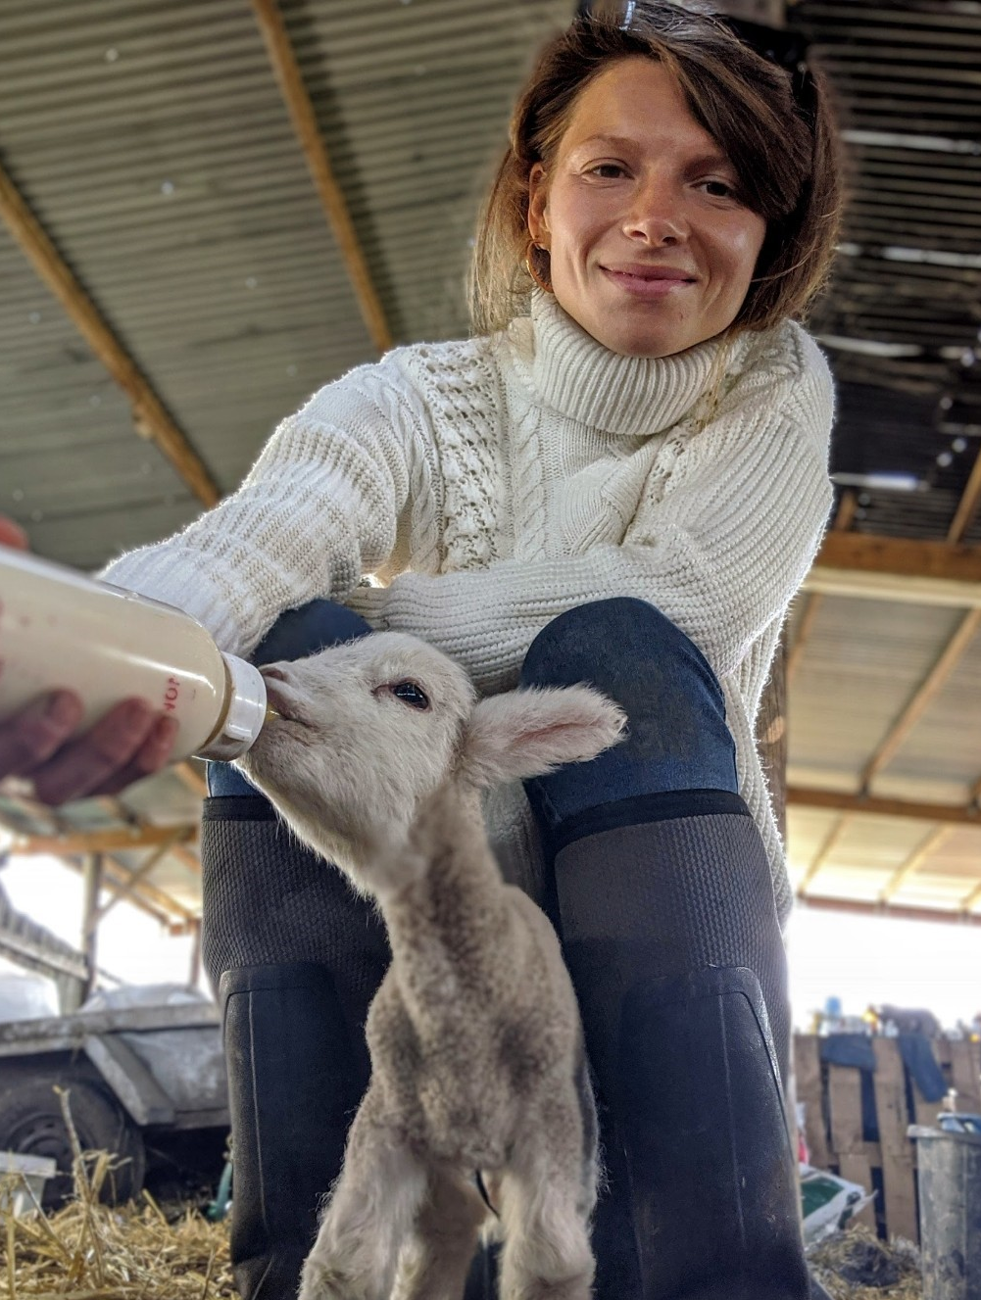
Zoë Colville, Shepherdess

What qualifications do you have?
GCSEs, NVQ Level 3 in hairdressing, plus a load more
None in farming but a few for the butchery, food hygiene and HACCP.

What does your job involve?
Feels like a lifestyle more than a job, if I'm honest. It involves such a varied range of activities and roles, which make every day different and exciting. For example, I may be the farmer, the vet, the mother and the caregiver all in one day.

We have built our rented farm up so we run about 30 cattle and over 1,000 ewes and lambs now, so they take a lot of work – just the checking of livestock and watering alone can take hours of the day as we rent land in about seven locations. Then we have the goats getting into mischief to contend with and no doubt an escapee sheep late on a Sunday night!

What, or who, inspired you to take your chosen career pathway?
It's a difficult one because Christopher, my boyfriend, grew up on his dad's farm, so when he decided to go back into farming from plumbing, it was quite a shock. I was a full-time hairstylist in London. So I lived both lives for a few years, so it wasn't a “WOW I need to farm” moment; I fell in love with the life and adapted very slowly, until, just over two years ago, I ditched the hairdressing and decided farming’s what I wanted to do. So, Chris probably, and watching how much of a meaningful path it would be.

What route did you take from leaving school to your current job?
The route was more like a rabbit warren of tunnels! I left school to do photography and art at UCA, waste of time, quit and did an apprenticeship in hairdressing in Kent, got made redundant, so on a whim moved to London. Trained in Selfridges as a stylist, moved to a salon in Soho and did some editorial work. Met Chris and transitioned into farming with 32 in-lamb ewes and here we are today.

What is the key knowledge, skills and experience needed for your job?
Always be open to learn. I feel farming is still very old-school and stuck in its ways and now we are in a time where, due to keeping ourselves safe, and environmental factors, we need to adapt a little. So an open mind is always important. Skills I think you can learn as you go, just learning to “be” when around animals. I used to sit for hours and observe the sheep – they feed off your energy, weirdly enough. As much experience as you can get, take it, say yes to as much as you feel comfortable with and just have a go!

What is the best thing about your job?
The freedom. For so many years, I was so hung up on time or “appointment slots” and now there are few time restraints. I just do the jobs as and when they need doing – that flexibility is liberating. Plus, what other careers mean if you wake up on a Monday and decide you fancy rearing some calves, you can go and embark on that journey!

What questions are you often asked about your job?
What made you leave hairdressing for farming?
Because I weighed up my happiness vs what was stopping me (money) and decided that if you want something enough, you have to go for it. So even though we are completely broke, as long as we can eat and live, at least we are happy.

What's it like not being from a farming background?
I think it's sometimes a blessing because you aren't stuck in the family ways of doing things. It’s much easier to think outside the box because you have a completely clean slate and have to learn from scratch, hence coming up with some brilliant ideas and solutions. I don’t feel it’s affected me.

What advice would you offer to someone interested in doing what you do?
Take a big deep breath and go for it. Send letters and emails and ask for experience, ask questions, read books, join Facebook forums, follow farmers’ Instagrams. And most importantly be brave. Any new path is daunting, but if you want it enough, you'll make it work for you. I never thought we would be opening a butchery and running a working farm, but we've managed it through determination and working our way through the rough patches – of which there are plenty – wet winters and dry summers! If you want it enough, it'll happen for you – you won't stop until you get somewhere you want to be, promise!

