Executive Chef

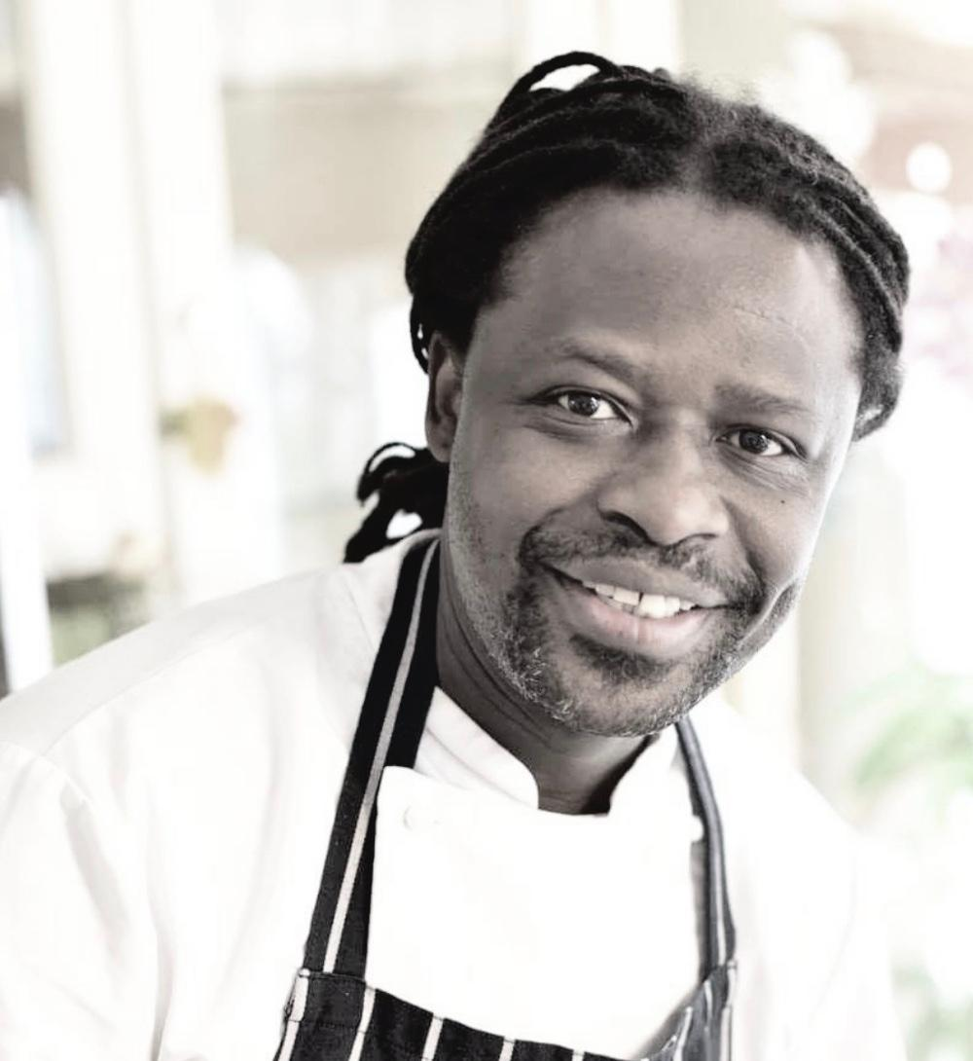
Dennis Mwakulua, Lexington Catering

What qualifications do you have?
7061& 7062 (equivalent to NVQ level 1&2), Advanced Kitchen Management (7 day course including work experience at a 7 star hotel – Burj al Arab),
FdSc Culinary Arts

What does your job involve?
- Managing all aspects of events, fine dining, hospitality, café, staff dining, grab & go bar
- Managing menu preparation and pricing in line with client compliance
- Developing new menus and food items to meet the taste and dining requirements of the clients
- Managing the preparation and presentation of food products to ensure quality at all times
- Implementing procedures to minimise wastage and overproduction
- Coaching and guiding new members of the team, putting in place proper orientation training and ongoing training and development for team members
- Managing all aspects of health, hygiene and safety

What, or who, inspired you to take your chosen career pathway?
I chose the hospitality industry through the influence of my dad, who worked in hotels as an F&B Manager. At the start of my career, it was professional chefs (Marcus Samuelsson and Wylie Dufresne) who inspired me. What inspires me today is the people who I work with. They play a bigger part in day-to-day cooking.

What route did you take from leaving school to your current job?
I started as a kitchen porter and made my way up the ladder through college studies, cooking estages (short work experiences at high end establishments), reading cooking books and a bit of travelling to different restaurants to understand food (ingredients).

What is the key knowledge, skills and experience needed for your job?
- Attend a good, reputable catering school to have a sound foundation
- Then find a good Michelin-starred restaurant for a career start as an apprentice/commis – just to listen and absorb. I would highly recommend three months to a year
- If possible, travel, starting with Lyon in France, Scandinavia, America and Asia (Japan) on 2-year estages in top restaurants

What is the best thing about your job?
The job gives me the freedom to innovate and experiment with dishes. Then there is job security. I know that technology will not be able to create what we do in the kitchen soon. There is satisfaction when I see my cooking bring communities together and making a difference in supporting those who are less fortunate. The job allows me to be a role model and achieve a sense of bigger responsibility.

What questions are you often asked about your job?
What is a salary expectation? How long is the shift? Will I have to work on weekends? How do I manage such a big brigade?

What advice would you offer to someone interested in doing what you do?
You will have job security for life, with the ability to travel around the world and network with your fellow professionals. You have freedom to explore and express yourself with no limitation.

