Junior Product Developer

Sam Griffiths, Co-op
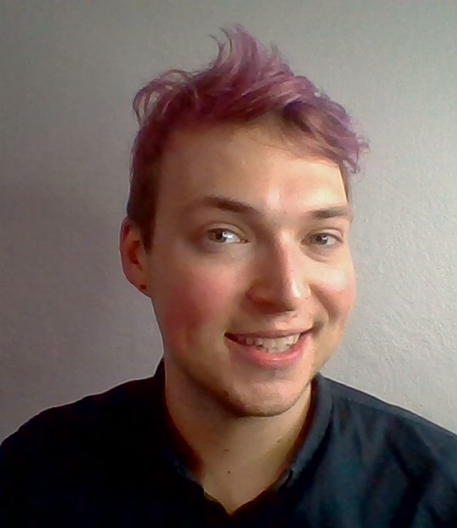

What qualifications do you have?
GCSEs including Food Technology & A-Levels including Food Technology,
BSc Food & Nutrition at Sheffield Hallam University

What does your job involve?
I manage and create new products for launch throughout the year for the areas I cover. It involves creating new ideas, trying new and innovative products and reviewing products & places to eat (including food festivals). Once these have taken place we then develop the product with our suppliers and take it through the process for launch and then help market this product to the right consumers and stakeholders. Following that we then review the product and market then the process starts again for the following year.

What, or who, inspired you to take your chosen career pathway?
I was inspired mainly by my passion for food and my mum. We were encouraged from a young age to try new things and we often went abroad and had to try the local cuisine. This sparked my involvement with food from a child as I tried many different flavours, cooking techniques and ingredients. Growing up we then hosted many dinner parties for friends/family and experimented with different cuisines and often cooked together producing wonderful exciting meals. Then in high school my passion exploded through my involvement with the food tech department and I followed it through to my career.

What route did you take from leaving school to your current job?
From leaving school I decided to go to University to study food and nutrition, during the 3rd year I applied for a placement year within the Co-op which I secured and became a great help to them so far that my placement was extended by 3 months to help them finish projects. I then finished Uni and received a job offer from Greencore (a Co-op supplier that I worked closely with on my placement year). This was so informative, and I learnt so much and made so many great contacts and friends but after a year I received another job offer from Co-op to become a Junior Product developer with them, and now I’m here nearly 2 years in.

What is the key knowledge, skills and experience needed for your job?
I’d say the most important thing needed to get into the food industry and development is an interest and passion for food. Experience is always a plus and any experience within the food industry is beneficial. If you’re doing a degree in University try to get a placement year as this is very much worth it as you learn so much, but you also make so many contacts within the industry, and with it being small it’s always worth it.

What is the best thing about your job?
The best thing about my job is the food, the ones we develop and the ones we try; we try many different products and experiment with many different chefs trying new ingredients, cooking techniques and products. We go out to restaurants, events and festivals to try all different foods. This just fuels my passion for trying new things and allows me to get excited about products I’ve developed and wait for them to appear on shelf. However, you can’t beat that feeling when you’re in a shop and see people buying your product.

What questions are you often asked about your job?
The most common question I get is ‘How is that a job?’ Or ‘How can I do that?’
To which my usual reply is: ‘Well someone has to do it. You just need a passion for food and once you have that you can work your way up. Having a degree in food helps but I wouldn’t say it’s essential as a lot of my colleagues have degrees in different areas, some not related to food. If you’re excited by food, enjoy trying new things and exploring new recipes this job can be for you.

What advice would you offer to someone interested in doing what you do?
If you’re really interested in becoming a product developer in the food industry, look around your local area and apply for product developer roles in local food businesses, they’re everywhere! If that’s not something you can do yet, work in food service, learn about the industry and explore what options you have. I also have a ‘portfolio’ where I use food magazines and things I believe are trends to keep myself updated and, in the loop, this is always received positively when going for interviews.

