Lecturer in Public Health Nutrition

Dr Sarah Bath, University of Surrey
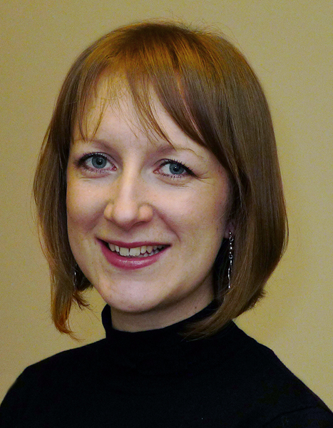
What qualifications do you have?
BSc in Nutrition and Dietetics (University of Surrey) with registration as a dietitian with the Health and Care Professions Council (HCPC)
PhD in Nutritional Sciences (University of Surrey)

What does your job involve?
My job is varied – no two days are the same, which makes it interesting! It involves both teaching and research. I teach undergraduate and postgraduate students who are studying for a qualification in a nutrition-related subjects (e.g. dietetics). I deliver lectures on a variety of subjects, including public-health nutrition, iodine, research skills, and statistics.

In my research I focus on iodine deficiency in the UK. I lead and work on studies in humans that aim to develop our understanding of iodine. I also supervise students who are working on their research projects. Research involves collecting and analysing data, then presenting results at conferences, and as a paper for publication in a scientific journal.

What, or who, inspired you to take your chosen career pathway?
I loved science subjects at school and particularly enjoyed biology. I found the topic of nutrition fascinating and wanted to learn more about how food and nutrients could influence health and disease. I wanted to become a dietitian so that I could combine the science of nutrition with translation to practical information and advice for patients and the public.

What route did you take from leaving school to your current job?
I did a four-year degree in Nutrition and Dietetics which led to a BSc qualification and registration with the Health and Care Professions Council (HCPC) so that I could practice as a dietitian. During the four-year degree, I spent time on several placements within the NHS to develop the skills required.

After graduation, I worked as a clinical dietitian in the NHS, in two acute hospital trusts. This involved seeing patients in the hospital and in outpatient clinics. After 18 months of working in the NHS, I made the decision to return to the University of Surrey to study for a PhD.

My PhD was on iodine status in UK pregnant women. It took just over three years and involved conducting a series of studies and writing up the findings as a thesis. I then continued to work in nutrition research (again on iodine), as a post-doctoral research fellow for four years before I started the position of Lecturer at the University of Surrey. My experience in the NHS was invaluable and has really helped me in my current job.

What is the key knowledge, skills and experience needed for your job?
I think it is important to be enthusiastic and passionate about the subjects you are teaching and researching. That really helps to keep focus and helps the students to engage with the lectures.

I would also say that good communication skills are essential – this includes both oral and written communication. Oral communication skills are needed when I speak in front of audiences (either when teaching or presenting research at a conferences), but also for one-to-one communication with students or other scientists. Good written communication skills are needed for a variety of outputs, ranging from scientific publications, to blogs, website articles, or pieces for the media.

What is the best thing about your job?
I find the teaching aspect of the job so rewarding. I really enjoy teaching students, getting to know them, and seeing them develop as they progress through their degree.

In terms of the research side of my job, I enjoy working with other people. Research cannot be done alone, so I work with other scientists from all over the world. This gives me a wonderful opportunity to develop my own knowledge and skills – I have learnt a great deal from other people.

What questions are you often asked about your job?
I’m often asked if being a dietitian only involves helping people to lose weight. Sometimes people are surprised to learn that dietitians work in many different areas, both in hospitals and the community. For example, dietitians provide nutrition support for those who cannot eat and drink – this involves calculating nutritional requirements and prescribing feed. They also work alongside the medical team in a range of specialities (e.g. diabetes, kidney disease). Of course, dietitians also work in other areas like research and teaching (such as my current role), public health, or in the media.

What advice would you offer to someone interested in doing what you do?
If you think you might be interested in research, use the opportunity of the research project (often in the final year of an undergraduate degree) to explore different aspects of research and consider whether it is something that you would want to take further. It was through my own final-year project in my BSc that I got a taste for research – and it also started my fascination with iodine!

