Food Education Teacher

Lloyd Henry, Ysgol Gyfun Gwyr in Swansea
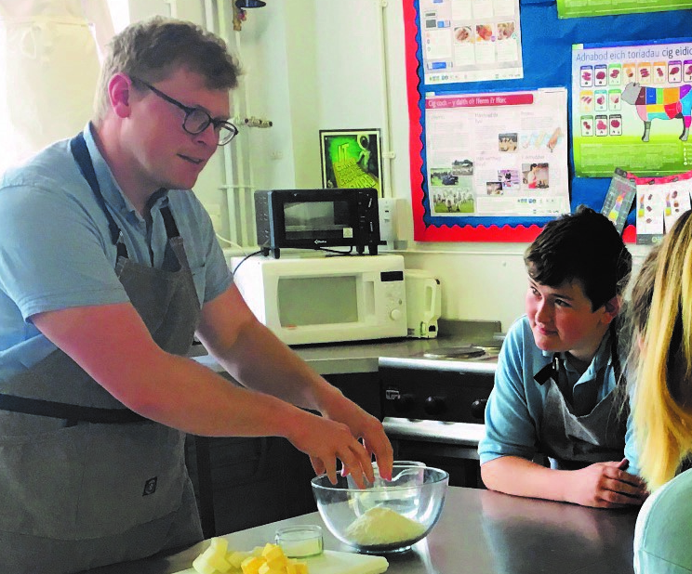

What qualifications do you have?
BA Hons International Hospitality Management
PGCE Secondary School Teaching

What does your job involve?
Lots of micromanaging, ensuring that pupils get the fullest experience possible in theory and practical lessons. I tend to think of myself as a chef, personal shopper, rugby coach, careers adviser all under the mantle of the word teacher. I am someone who is always willing to help within the Faculty, throughout the school and with the local community.

What, or who, inspired you to take your chosen career pathway?
I wouldn’t necessarily say it was a person but the love of food and my want to share this passion is what made me want to teach. I pride myself on being a positive role model who puts every effort into whatever I am asked to do. I enjoy being around people and like to think that my energetic personality motivates others. I have an eagerness to learn new skills and better myself every day and feel that being a teacher allows me to do this.

What route did you take from leaving school to your current job?
After leaving school I embarked on a degree at the University of Wales Institute Cardiff, studying International Hospitality Management. During my time there I had the opportunity to work in the United States at a private members golf club, both front of house and kitchen brigade duties. I have worked in a variety of roles in the hospitality industry, working my way up to junior manager for the Compass catering company at the Liberty Stadium Swansea. In 2007 I decided I needed to see the world and was lucky to get a job working as a Concierge and Receptionist at the Swiss Grand Hotel Bondi Beach in Australia. After gaining countless unforgettable experiences across the world I then began my teachers training in 2009.

What is the key knowledge, skills and experience needed for your job?
From experience in both industry and education I have gained, improved and developed a variety of skills, having a methodical and logical approach to work requirements is what I have found beneficial. Good communication skills and listening abilities as well excellent organisational and planning skills, are at the forefront of any good teacher. Having a keen interest in technological developments and ever-changing food trends is key to keeping the subject current. Be proactive in seeking and providing opportunities for yourself and your pupils and believe in a ‘can do’ attitude.
What is the best thing about your job?
Every day is different, so starting fresh every day, which is both exciting and daunting at the same time. You get to cook pretty much every day, seriously how cool is that? No two lessons are the same, so what could have been a disaster one lesson can be a success the next time, pupils genuinely love to cook and nothing brings more joy than seeing a pupil who in year 7 that had very little or no skills completing a 2/3 course meal for their assessments at the ages of 16 and 17.

What questions are you often asked about your job?
What have you cooked today? Was it your class that set off the fire alarm? How do you manage with so many pupils in so little time? Did the kids really make that? Yes!

What advice would you offer to someone interested in doing what you do?
Be two steps ahead, I find using short term targets for long term goals are the best way forward. It’s all well and good planning out the whole year, but nobody factors in absences, forgotten ingredients, lost books. Know what you are doing, be confident about it, and share your enthusiasm for the subject with the school not just your class. Set the bar high, if you lead well people will follow.

