Trade Marketing Executive

Martin Eccles, Agriculture & Horticulture Development Board (AHDB)

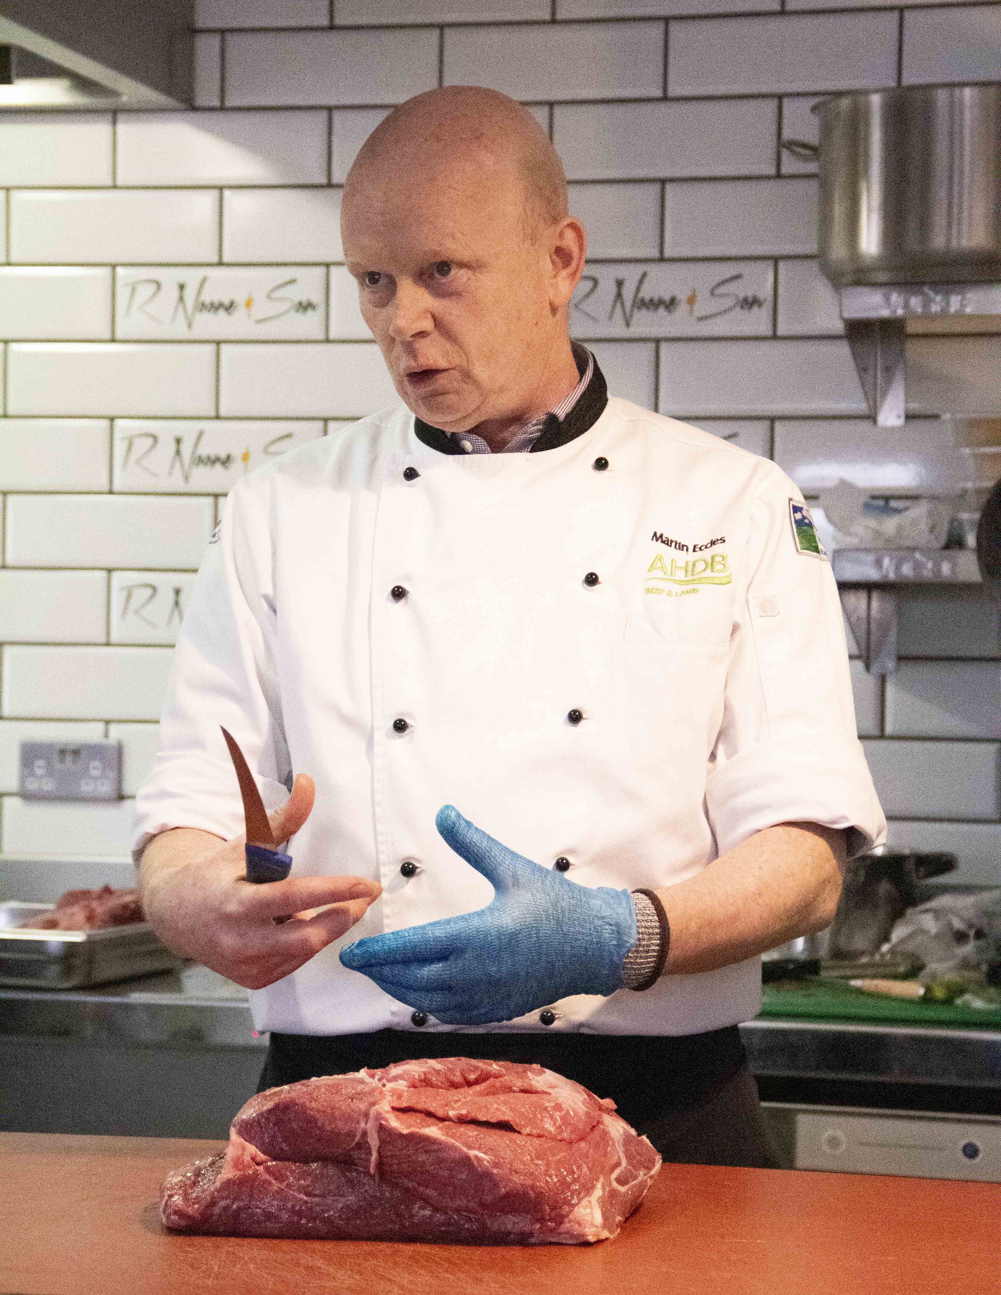
What qualifications do you have?
The Royal Institute of Public Health - Intermediate Certificate in Food Safety, IOSH Managing Safely and Food Hygiene Level 2

What does your job involve?
Looking at ways in which we can improve all aspects of the meat trade. This may involve delivering a butchery demonstration on new cutting methods. How to optimise yields. Offering industry knowledge to colleagues, representing AHDB at industry events in the UK and abroad.

What, or who, inspired you to take your chosen career pathway?
Once I started work in the local butchers, I found the whole trade fascinating, there is always something new to learn, whether it be a cut or a cooking method. I loved the fact that I could produce something that, whoever bought it, would enjoy.

What route did you take from leaving school to your current job?
I started work cleaning up in a local butchers at 14, and then at 16 I started full-time. I worked there for 25 years. From 2001-2009, I worked at Kepak meat processing plant, which was taken over by Dunbia. I worked in all departments including abattoir, Quality Assurance, beef and lamb cutting rooms, retail cutting and production. From 2009-2010, I worked in a catering butchers. From 2010-2011, I worked in a butcher’s shop and in 2011-2012, I returned to Dunbia running a lamb cutting room. From 2012 to now I have worked at AHDB.

What is the key knowledge, skills and experience needed for your job?
Being able to change because consumer demands are constantly evolving, so you need to be able to keep up. When I worked in the butcher’s shop, I got a fantastic grounding into customer service. I understood the value of what I was doing. When I moved to the commercial side of the meat industry, I had to learn a completely different way of working but the core skills I had gained helped me to progress. All the hard work has got me to where I am today.

What is the best thing about your job?
I get to work with and meet some fantastic people who have the same passion for not only the meat industry but also for food in general. I have been fortunate enough to travel with my job so have seen how other nations differ from us – there is nothing more satisfying than adopting a new method of doing something.

What questions are you often asked about your job?
How do you get your knives so sharp? How do you make it look so easy? Where can I learn how to do that?

What advice would you offer to someone interested in doing what you do?
Go for it, get a good grounding, learn the basics as these will serve you all your life. Listen to what people have to say and always be open to change.

