Technical Milling Coordinator

Liam Melton, Whitworth Bros. Ltd Flour Millers
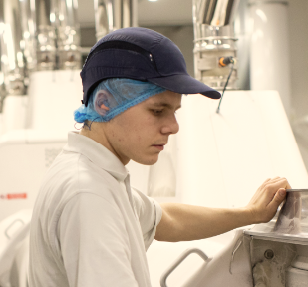

What qualifications do you have?
nabim Intermediate Certificate in Flour Milling;
Level 1 NVQ, Motor Vehicle Engineering;
Level 2 Food Safety in Manufacturing; Level 2 Principles of HACCP

What does your job involve?
My job involves coordinating all milling operations at the Wellingborough plant. This includes full responsibility for flour production, planning of mill maintenance, ensuring the mills are maintaining good extraction and product quality, customer interaction, accompanying audits and providing technical support to the shift milling team.

What, or who, inspired you to take your chosen career pathway?
A family member has worked at Wellingborough for over 40 years and is currently the mill’s supply chain manager. When I was leaving school, she suggested I come in to do some work experience. The job was to help with filing, but the more I learned about what went on at the mill, the more I was inspired to work there. I’ve always been technically minded, and I saw that there were lots of opportunities within the mill that would help me develop my skills.

What route did you take from leaving school to your current job?
After leaving school, I attended a local college to secure an NVQ in Motor Vehicle Engineering, but then a job came up at Whitworths for a lab trainee. From there, it was a case of working up through the ranks and gaining as many qualifications as possible.

What is the key knowledge, skills and experience needed for your job?
You need to have two or more years of hands-on milling experience. The job takes time to learn and only gets easier with experience – but if you’re keen and committed, a quick learner, a team player and computer literate, you have all the basics to make a successful career in the industry. My ambition now is to build up experience within the management structure to take the next step with Whitworths.

What is the best thing about your job?
Every day is different, throwing up new and exciting challenges.

What questions are you often asked about your job?
Many people buy flour from the supermarket without ever questioning where it came from, and if they are aware of the flour milling industry, they think we’re still working in windmills! When I tell them about the technology involved, they’re amazed. People from outside the industry always seem to be fascinated by what I do.

What advice would you offer to someone interested in doing what you do?
I would heartily recommend it, and I do so whenever I’m asked to speak to local school children about my job. The industry is largely unknown, yet within it there is scope to do so much, whether it’s sales or engineering. It’s a fantastic career and a great opportunity for young people.

