Quality assurance

1. What does the term ‘quality assurance’ mean? Give some examples of schemes that are used for ingredients and food products.

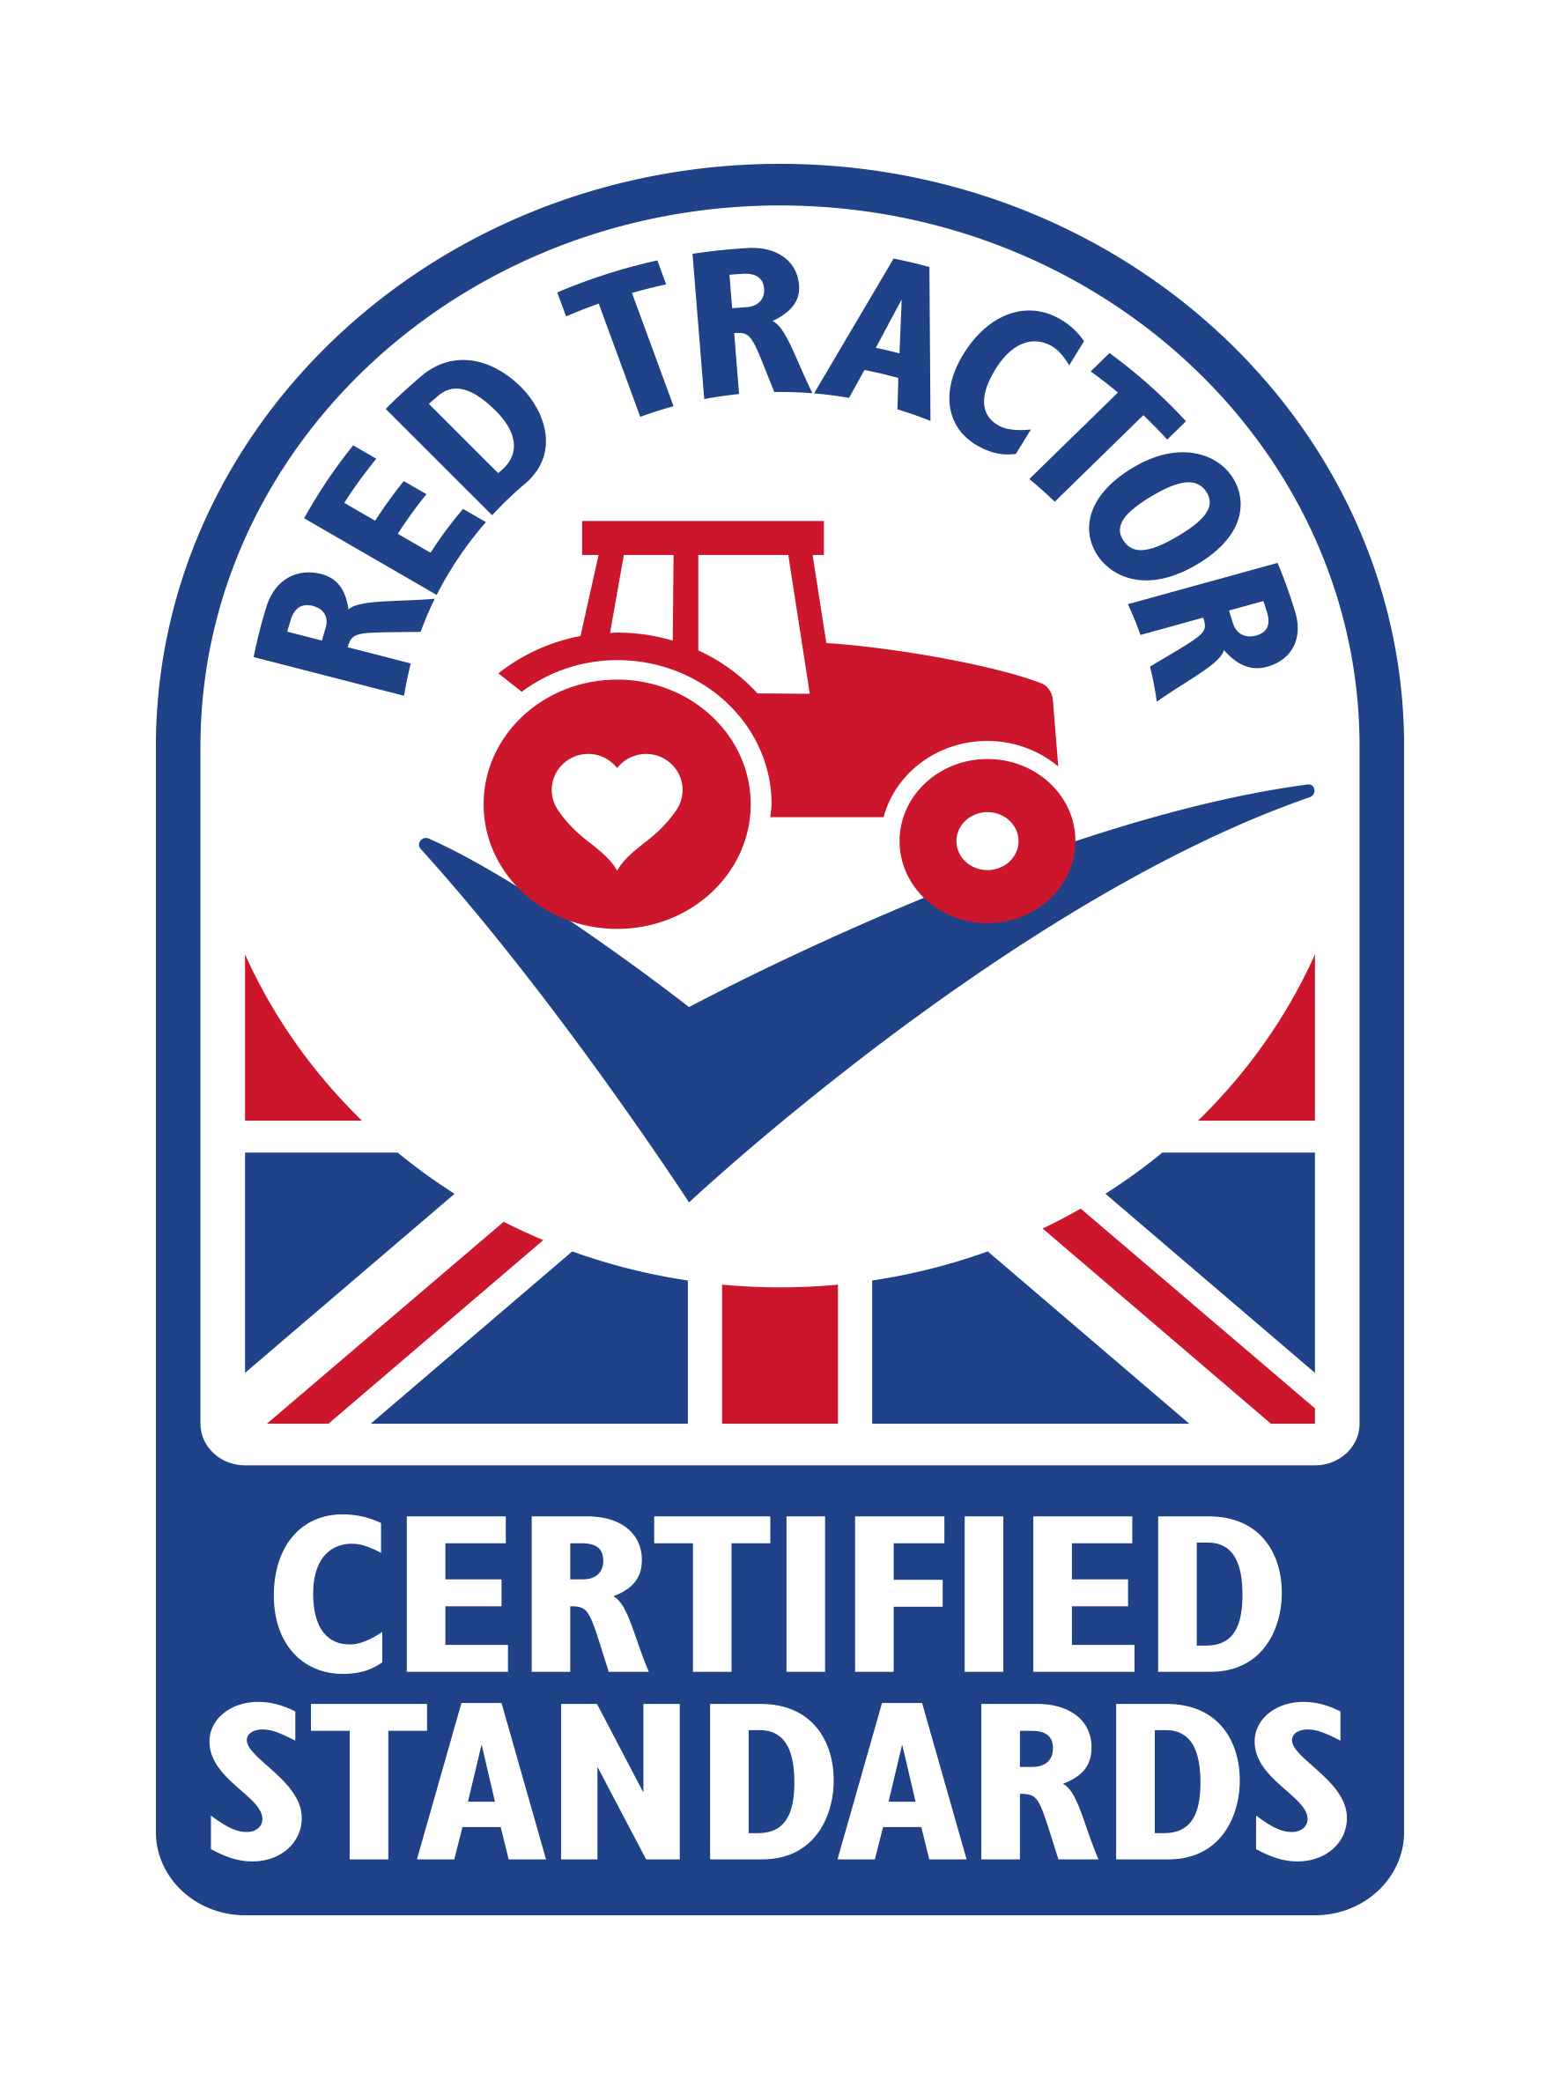
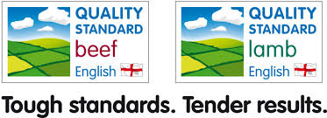
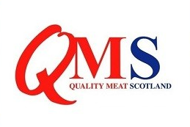
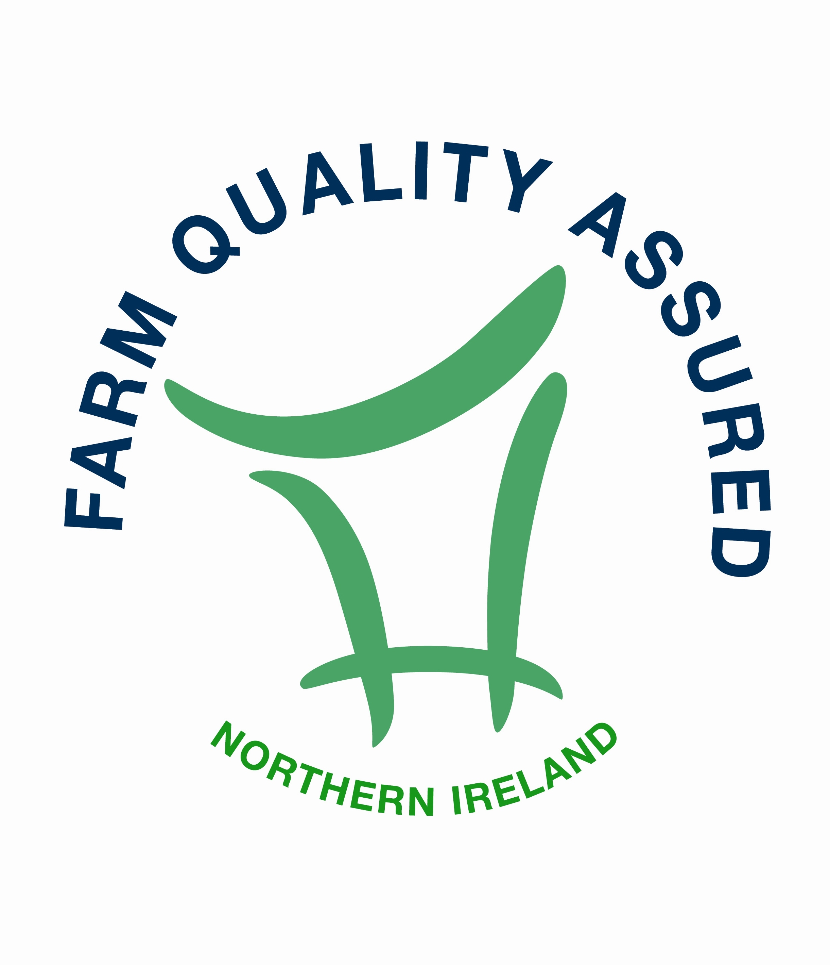

2. Research the following quality marks that you might see on red meat products. Explain what they might mean to a consumer.

