Breakfast trifle
Complexity: Low

Ingredients

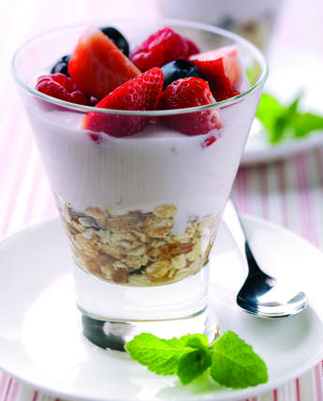
150g muesli

120ml apple juice

450g strawberry yogurt

350g mixed seasonal fruits

Equipment
Spoon, glasses.

Method
- Place the muesli in the base of four glasses.
- Spoon 2 tablespoons of apple juice over each.
- Spoon over the yogurt and top with fruit.

Food skills
Mix, stir & combine

