Oaty apple and orange squares

Ingredients
Complexity: Low-medium
150g butter, softened
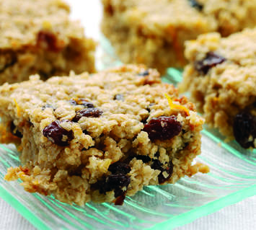
100g demerara sugar
200g rolled oats
90ml unsweetened apple juice
1 orange, zest only
100g raisins

Equipment
20cm square cake tin, spoon, bowl, knife, cooling rack.

Method
- Preheat the oven to 180⁰C, Gas Mark 4 and grease a 20cm square cake tin.
- Cream the butter and sugar until light and fluffy, then work in the oats and add the apple juice, orange zest and raisins.
- Tip into the prepared tin and spread evenly and bake for 25 to 30 minutes until golden brown.
- Cool slightly before marking into squares.
- Leave to cool in the tin before cutting into squares.

Top tips
- Store in an airtight tin.

Food skills
Weigh
Cream
Mix, stir & combine
Cut
Bake

