Breakfast energy bars

Ingredients
Complexity: Low-medium
100g butter
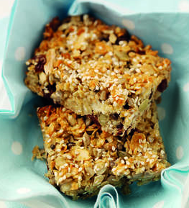
200g clear honey
200g rolled oats
150g mixed seeds
100g toasted flaked almonds
100g sultanas
50g ground almonds
2 x 5ml spoon sesame seeds

Equipment
Saucepan, spoon, 22cm square baking tin, oven gloves, cooling rack.

Method
- Preheat the oven to 180C, Gas Mark 4.
- Heat the butter and honey in a saucepan until the butter has melted.
- Stir in the remaining ingredients except sesame seeds and press into a 22cm square baking tin.
- Sprinkle over the sesame seeds.
- Bake for 15 minutes until golden.
- Allow to cool slightly before cutting into 12 bars.
- Leave in the tin to cool completely before removing.

Top tips
- Store in an airtight container.

Food skills
Weigh
Melt
Mix, stir & combine
Bake
Cut

