Muesli breakfast biscuits

Ingredients
Complexity: Medium
100g butter, softened
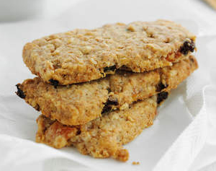
25g golden caster sugar
1 medium egg yolk
50g oats
25g oatmeal
75g wholemeal plain flour
½ x 5ml spoon baking powder
25g dried apricots, chopped
25g sultanas

Equipment
2 x baking trays, whisk, 2 x bowls, rolling pin, knife, cooling rack

Method
- Preheat the oven to 160⁰C, Gas Mark 3. Line 2 baking trays with greaseproof baking paper.
- Whisk the butter and sugar together until pale and fluffy. In a separate bowl, mix together the remaining ingredients and then mix into the butter mixture to make a firm dough. Chill in the fridge for 10-15 minutes.
- On a floured surface, roll or press out the dough to a 22 x 16cm rectangle, cut into 12 biscuits. Place on the prepared trays and bake for 15-20 minutes until golden. Cool slightly before transferring to a cool rack.

Top tips
- Wrap 2-3 biscuits in paper and ribbon for a great breakfast on-the-go.

Food skills
Whisk
Mix, stir & combine
Roll out
Cut

