Spinach, herb and potato omelette

Ingredients
Complexity: Medium
2 potatoes, peeled (approx. 250g)
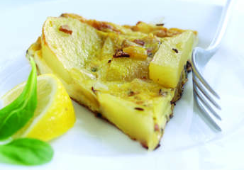
Half an onion, chopped
1 clove garlic, chopped
1 x 5ml spoon caraway seeds
3 medium eggs, beaten
25g spinach leaves
1 x 5ml spoon chopped sage
2 x 5ml spoon chopped thyme

Equipment
Saucepan, sharp knife, non-stick frying pan, spatula, knife.

Method
- Boil the potatoes in a saucepan of water and once cool thinly slice them.
- In a non-stick pan gently fry the onion, garlic and caraway seeds for 3 to 4 minutes until soft and add in a drizzle of olive oil.
- Add half the roughly chopped spinach.
- Cook for a further minute to allow the spinach to soften.
- Add the potatoes, sage, thyme and tumeric and season.
- Add the beaten eggs and fry gently for 5 minutes.
- Finish off under a preheated grill for 1 minute
- Once cooked turn out onto a plate.

Food skills
Melt, simmer & boil
Fry
Grill

