Devilled tomatoes on granary toast

Ingredients
Complexity: Low-medium

450g cherry tomatoes

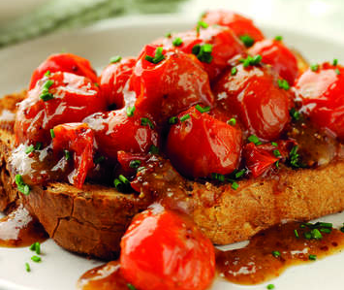
2 x 15ml spoon mango chutney pieces, chopped

1 x 15ml spoon Worcestershire sauce

1 x 15ml spoon wholegrain mustard

1 x 15ml spoon orange juice, freshly squeezed

1 x 15ml spoon chives, chopped

1 x 15ml spoon vegetable oil

2 chunky slices granary toast

Pinch of salt

Equipment
Bowl, spoon, frying pan, toaster.

Method
- Mix together the chutney, Worcestershire sauce, mustard, orange juice and a pinch of salt.
- Heat the vegetable oil in a frying pan and fry the tomatoes for 4-5 minutes, stirring frequently until slightly softened.
- Add the mustard mixture and cook, stirring for a further 4-5 minutes or until the sauce has thickened. Meanwhile put the toast in the toaster.
- Spoon over warm toast, sprinkle over the chives and serve immediately.

Top tips
The mustard and Worcestershire sauce give quite a hot, spicy flavour, so reduce these for a milder taste.

Food skills
Mix, stir & combine
Fry
Layer
Decorate & garnish

