Oatmeal loaf

Ingredients
Complexity: Medium
200g strong wholemeal bread flour
250g strong white bread flour
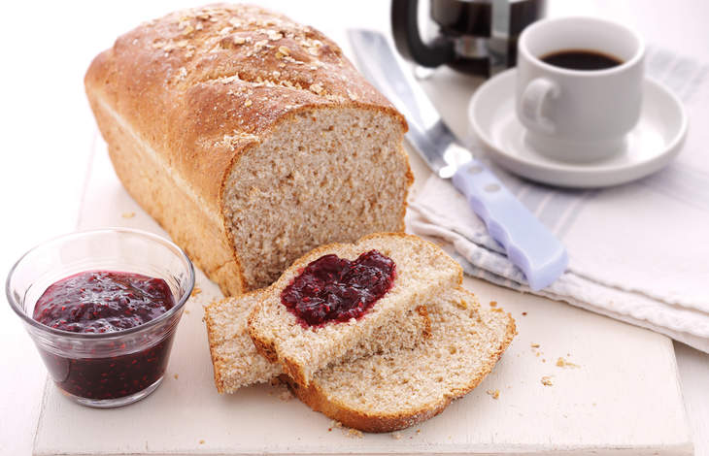
25g oatmeal
25g oats + 1 x 15ml spoon
7g sachet dried yeast
1 x 5ml spoon salt
1 x 15ml spoon clear honey
2 x 15ml spoon vegetable oil

Equipment
Large mixing bowl, spoon, 2 x bowls, 1kg loaf tin, cooling rack.

Method
- Mix the flours, oatmeal, 25g oats, salt and yeast in a large bowl.
- In a separate bowl, mix 300ml warm water with the honey and oil and stir into the flour to form a dough.
- Knead on a floured surface for 10 minutes until smooth and elastic. Place in an oiled bowl, cover and leave in a warm place for 30 minutes - 1 hour until doubled in size.
- Preheat the oven to 200C, Gas Mark 6. Grease a 1kg loaf tin.
- Knock the dough back and mould into a rough loaf shape to drop into the prepared tin. Cover and leave for 30 minutes or until doubled in size.
- Sprinkle with the remaining oats and bake for 30-35 minutes until golden. Remove from the tin and cool.

Top tips
- Simply roll into a large round shape and place straight on a greased baking tray and bake instead of using a loaf tin.
- The loaf will keep for 1-2 days in an airtight container.

Food skills
Mix, stir & combine
Knead
Prove
Form & shape
Bake

