Wholemeal cottage loaf

Ingredients
Complexity: Low-medium

600g strong wholemeal bread flour

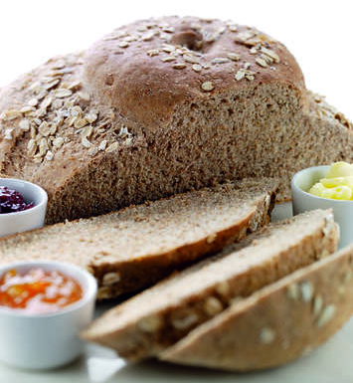
1 x 5ml spoon salt

7g sachet dried yeast

400ml tepid water

1 x 15ml spoon milk

1 x 15ml spoon jumbo porridge oats

Equipment
Bowl, jug, baking tray, pastry brush.

Method
- Mix the flour, salt and yeast in a bowl.
- Stir in water to form a dough.
- Knead on a floured surface for 10 minutes until smooth.
- Remove a quarter of the dough and roll into a ball.
- Roll the large piece of dough into a ball and place on a greased baking tray, top this will the smaller ball.
- Brush with a little milk and sprinkle over the oats.
- Allow to prove for 30-40 minutes until double in size.
- Preheat the oven to 200⁰C, Gas Mark 6.
- Bake for 30-35 minutes until golden and hollow when the base is tapped.

Top tips
Divide the dough into 8 to make individual rolls and reduce the cooking time to 20-25 minutes until golden.

Food skills
Mix, stir & combine
Knead
Prove
Bake

