Banana and honey breakfast loaf

Ingredients
Complexity: Medium

75g butter, softened

75g caster sugar

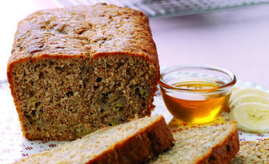
1 large egg, beaten

225g wholemeal flour

2 tsp baking powder

3 medium ripe bananas, mashed

2 x 15ml spoon clear honey

Equipment

1kg loaf tin, whisk, 2 x mixing bowls, spoon

Method
- Preheat the oven to 180⁰C, Gas Mark 4.
- Grease and base line a 1kg loaf tin.
- Whisk the butter and sugar together until pale and fluffy.
- Gradually whisk in the egg.
- Mix the flour and baking powder together and fold into the butter mixture.
- Stir in the bananas and honey.
- Spoon into the prepared tin and bake for 40-45 minutes or until firm to the touch and a skewer comes out clean.
- Allow to cool slightly before removing from the tin.

Food skills
Whisk
Mix, stir & combine
Bake

