Honey and walnut bread

Ingredients
Complexity: Medium-high

250g strong wholemeal flour

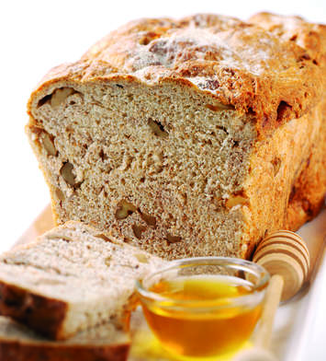
250g strong white flour

2 x 5ml spoon easy-blend dried yeast

1 x 5ml spoon salt

4 x 15ml spoon clear honey

25g butter, melted

100g walnut pieces, lightly toasted

Equipment

900g loaf tin, large bowl, round bladed knife, bowl, clingfilm, pastry brush, sharp knife, wire rack.

Method
- Grease a 900g loaf tin.
- Put the flours, yeast and salt in a large bowl.
- Add the honey, butter and 250ml hand hot water.
- Mix to a soft dough with a round bladed knife, adding a dash more water if the dough feels dry.
- Knead on a floured surface for 10 minutes until smooth and elastic. Alternatively use a table top mixer, fitted with a dough hook, and knead for 5 minutes.
- Add the walnuts and knead until evenly distributed.
- Put the dough in a lightly oiled bowl, cover with clingfilm and leave in a warm place for about 1.5 hours or until doubled in size.
- Punch the dough to deflate it and tip out onto the work surface.
- Shape into an oval and drop the dough into the tin.
- Cover loosely with greased clingfilm and leave to rise for a further 1 hour.
- Preheat the oven to 200⁰C, Gas Mark 6.
- Brush the top of the dough with water and sprinkle with a little wholemeal flour.
- Score the surface of the bread several times with a knife and bake for 30 minutes until risen and golden.
- Turn the loaf out of the tin and tap the base, it should sound hallow. If necessary, bake for a little longer.
- Cool on a wire rack

Top tips
Try using mixed seeds e.g. sunflower, pumpkin and linseeds, lightly toasted instead of the walnuts.

Food skills
Mix, stir & combine
Knead
Prove
Form & shape
Bake

