Eggy bread with fruit kebabs

Ingredients
Complexity: Low-medium

1 medium egg

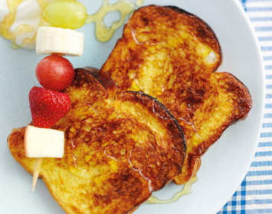
1 x 15ml spoon semi-skimmed milk

4 slices brioche

Selection of fruit (e.g. grapes, banana, strawberries, apple)

150ml natural yoghurt

1 x 15ml spoon clear honey

Equipment
Large bowl, fork, grill pan, baking paper, wooden skewers.

Method
- Beat the egg and milk together and soak the brioche in it.
- Place the bread on a grill pan lined with baking paper and place under a preheated grill, cook for 2-3 minutes each side until golden.
- Meanwhile, thread alternative pieces of fruit of your choice onto 2 wooden skewers or 4 cocktail sticks and place on top of the eggy bread.
- Drizzle yogurt with the honey and serve with the eggy bread and fruit kebabs.

Top tips
Try using a thick slice of white farmhouse bread instead of the brioche.

Food skills
Beat
Grill
Decorate & garnish

