Chia breakfast pots
Complexity: Low-medium

Ingredients

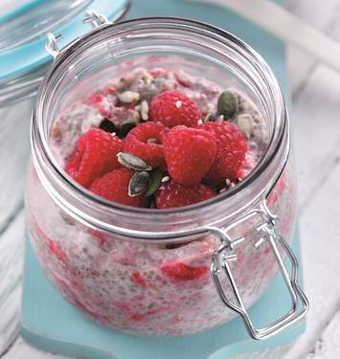
1 earl grey tea bag

250ml milk

50g chia seeds

25g oats

175g raspberries

4 x 15ml spoon natural yogurt

1 x 5ml spoon mixed seeds

Equipment
Cup, small saucepan, spoon, serving dishes.

Method
- Steep the tea bag in 50ml boiling water for 1 minute, remove the bag.
- Place the milk, chia seeds, oats, raspberries (reserving a few for garnish) and tea in a small saucepan and bring up to a simmer, cook gently for 2-3 minutes, stirring. Cool slightly.
- Stir in the 2 tablespoons yogurt, transfer to two serving dishes and cool for 30 minutes or longer.
- Top with remaining yogurt and raspberries and sprinkle over the seeds.

Top tips
Alternatively, spoon into two storage jars and top with fresh raspberries for an on-the-go breakfast.

Food skills
Mix, stir & combine
Layer
Decorate & garnish

