Pear and cinnamon bircher muesli

Ingredients
Complexity: Low-medium

100g jumbo oats

100g mixed dried fruits (e.g. 50g dried cranberries, 50g sultanas)

25g almonds, roughly chopped

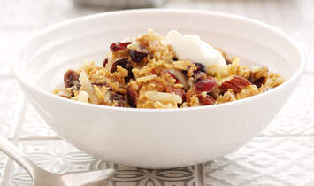
½ x 5ml spoon ground cinnamon

2 x 15ml spoons clear honey

200ml semi-skimmed milk

2 ripe pears, cored and grated

Equipment
Mixing bowl, spoon, large baking tray.

Method
- Preheat the oven to 160⁰C, Gas Mark 3.
- Mix together the oats, dried fruit, almonds and cinnamon and spread out on a large baking tray.
- Drizzle over the honey and mix to evenly coat.
- Bake for 15 minutes until golden. Allow to cool.
- Stir in the milk and allow to soak, in the fridge ideally, overnight.
- Stir in the grated pears and serve with yogurt or a little extra milk.

Top tips
Great for on-the-go breakfast, simply place in a sealed pot or container with a little natural yogurt.

Food skills
Mix, stor & combine
Bake

