Veggie taster
Taste these vegetables. Colour a face to show what you think. How many smiley faces will you get?

Child’s name:______________________________

courgette  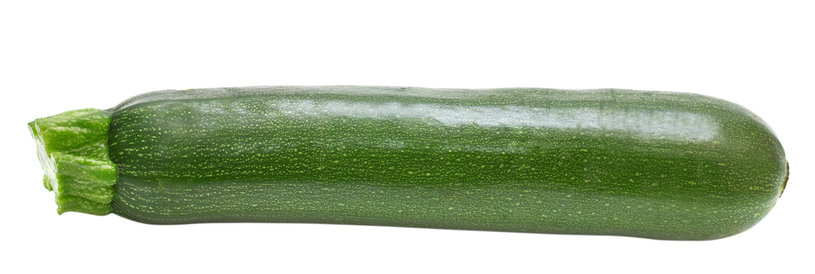 | 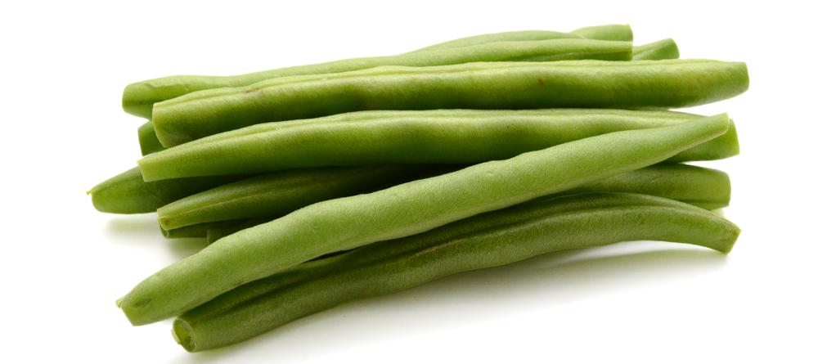  green beans | 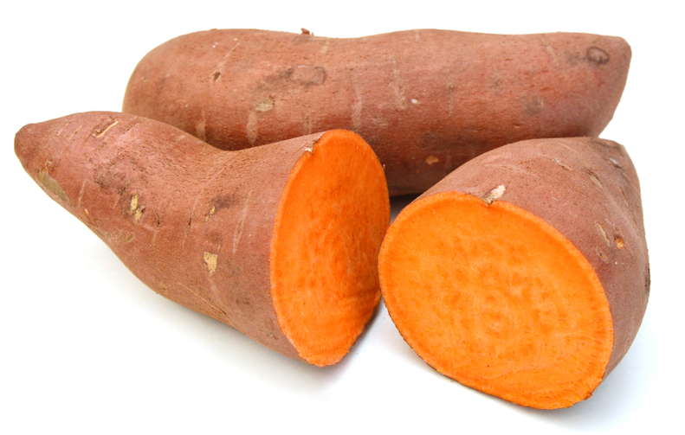  sweet potato


aubergine  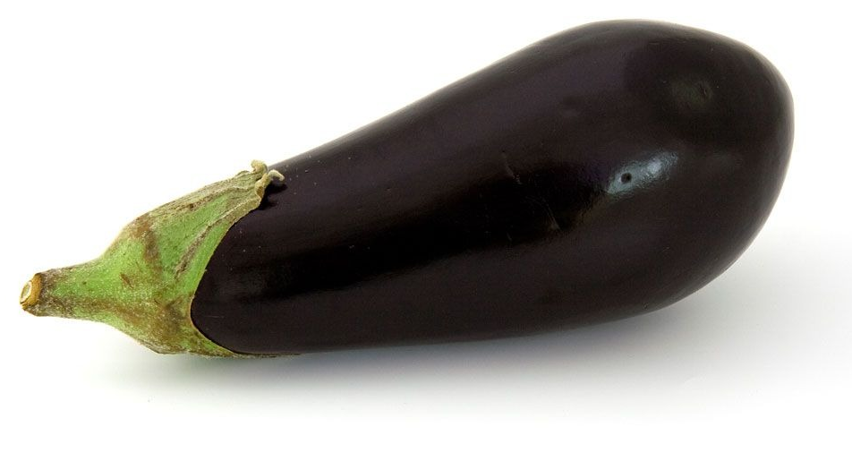 | lettuce  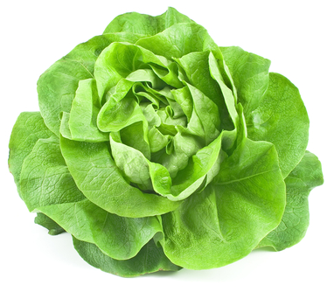 | 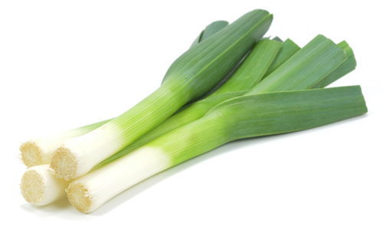  leek

Adults name:_______________________________

courgette | green beans | sweet potato
aubergine | lettuce | leek

