‘C’ veggie treasure hunt

Lots of vegetables being with a ‘c’.

Name all the vegetables below.

Next time you go to the shops see how many you can find!

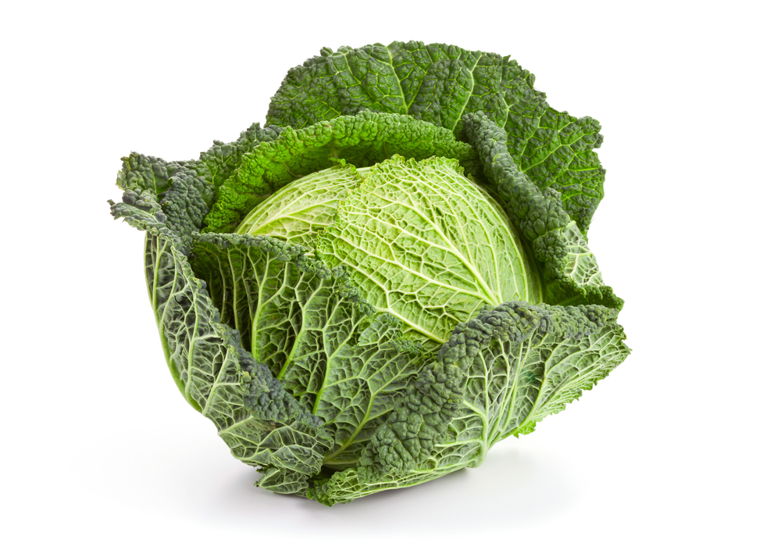 | 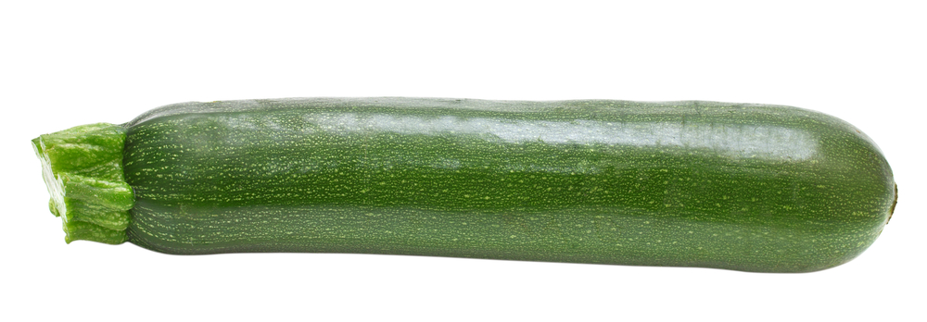
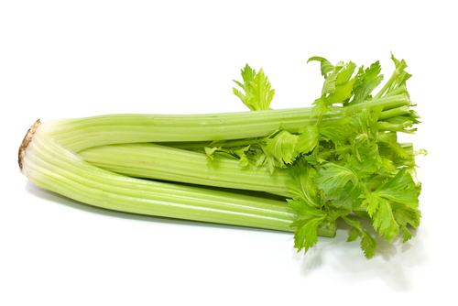 | 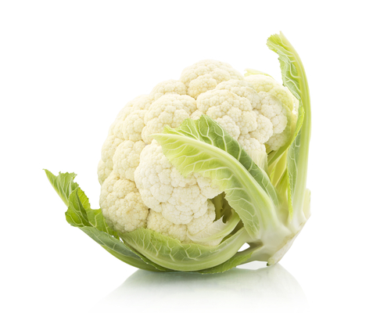
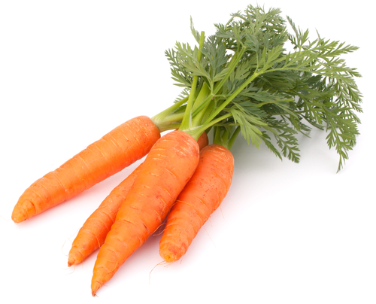 | Find another ‘c’ vegetable.  and draw it above.

