Which veggie am I?
Cut out the cards.

Match each vegetable to the correct description.

Name each vegetable.

I look like a white carrot! | 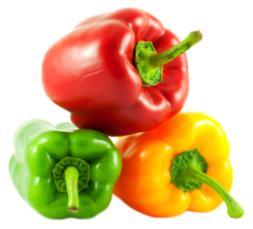
I look like a small cabbage and people eat me at Christmas. | 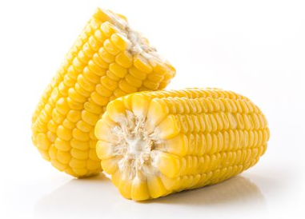
I’m yellow and bobbly! | 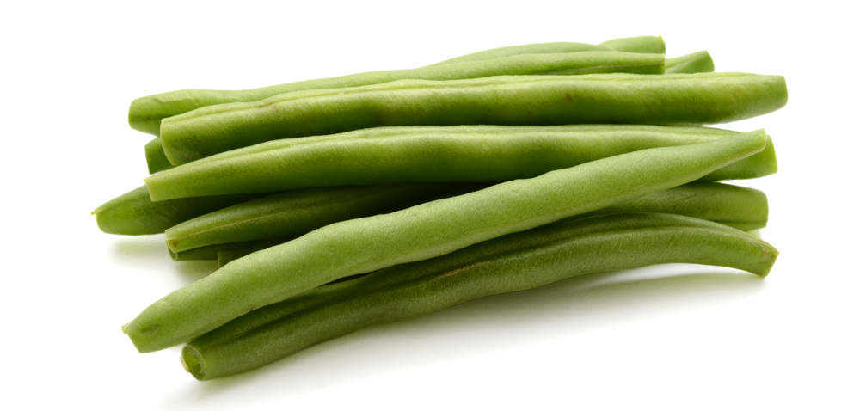
I’m shiny and I can be red, yellow, orange or green! | 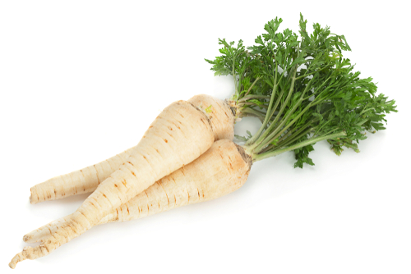
I am thin and green. | 