Veggie bingo!

Colour each vegetable you eat this week.

Who eat them all and be the winner?

Child’s name:______________________________

    lettuce |   pepper | 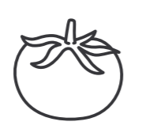  tomato
carrot |   green beans |   broccoli

Adults name:_______________________________

lettuce | pepper | tomato
carrot | green beans | broccoli

